**Project Documentation**

*of*



**Team Members**

Abhik Bhattacharjee(1505040)

Rudaiba Adnin(1505032)

Bishal Basak Papan(1505043)

**Under the Supervision of**

Sakshar Chakravarty

Lecturer

Department of Computer Science and Engineering

Bangladesh University of Engineering and Technology

**Table of Contents**

Vision Statement 4

Software Requirement Specification 6

1 Introduction 6

***1.1    Overview*** 6

***1.2    Goals and Objectives*** 6

***1.3   Scopes*** 7

***1.4   Definitions*** 7

2 General Design Constraints 7

***2.1       eMarketPlace Website Environment*** 7

***2.2       User Characteristics*** 8

***2.3       Mandated Constraints*** 8

3     Nonfunctional Requirements 8

***3.1       Operational Requirements*** 8

***3.2     Performance Requirements*** 8

***3.3     Security Requirements*** 8

***3.4      Documentation and Training*** 8

**3.5      *External Interface*** 9

**3.5.1      User Interface** 9

4     Functional Requirements 9

***4.1     Required Features*** 9

***4.2     Optional Features*** 10

Software Project Management Plan 11

1 Overview 11

***1.1 Project Deliverables*** 11

***1.2 Assumptions and Constraints*** 12

**1.2.1 Assumptions** 12

**1.2.2 Constraints** 12

***1.3 Success Criteria*** 12

***1.4 Definitions*** 12

2 Startup Plan 13

**2.1 Team Organization** 13

**2.3 Technical Process** 14

**Tools** 14

3 Iteration Plans 15

***3.1 First Iteration*** 15

***3.2 Second Iteration*** 15

***3.3 Final Product*** 15

4 Control Plan 15

***4.1 Monitoring and Control*** 15

***4.2 Configuration Management Plan*** 16

5 Supporting Process Plans 16

***5.1 Test Plan*** 16

***5.2 Product Acceptance Plan*** 16

Architecture & Design 17

User Guide 32

# Vision Statement

Our developed system **eMarketPlace** is a website based software. We have developed this software considering some factors. The users of the software can be any person or organization willing to buy and sell products.

1. **Project Goals**

* To ease the troubles of people to buy and sell things online without any shop, without being present all the time.
* To save the time of customers by not going to the market to buy a product.
* To inform the customers about new products of different categories.
* To help the vendors advertise their products and expand their business.

1. **Project Scope**

* Customers can search and order product by name or category based on their choices. They can check the current order status too. They can provide reviews and ratings of the ordered product when the product has been delivered to them. They can also request for refund after they get their ordered product.
* Vendors can add new products and edit existing products information. They can add sale offer on products as they wish. They can also track the orders from their shops. They can also see the reviews and ratings of the products of their shops.
* Admin has the complete control to approve the requests of the vendors to join the system. They can add new product categories as well as subcategories and attributes accordingly. They can also see the comments and complaints from the users about the current system. They have the ability to monitor all the orders.

* The scope of digital/online payment of orders is not included in the system

1. **Milestones and Deliverables:**

* Database design and implementation.
* Designing sign in module, registration process of the website. Connection with database.
* Vendor’s Dashboard and product update module.
* Search products  interface
* Ordering of items.
* User’s home page completion.
* Review & rating feature , user’s module  and vendor’s module integration.
* Central  admin’s dashboard  & update module
* Three modules’ (user, vendor , admin) integration and testing.

**eMarketPlace** is very easy to use by people of all ages who can use a computer and have access to the internet. The system has proper authentication system both for the customers and the vendors. Ordering products through **eMarketPlace** is very easy and as a consumer can not give reviews and ratings on a product until they get the product in his hand, the probability of providing fake reviews are reasonably low.

# 

# Software Requirement Specification

Revision History

|  |  |  |  |
| --- | --- | --- | --- |
| **Version** | **Date** | **Name** | **Description** |
| 1 | 09/12/19 | Rudaiba Adnin  Abhik Bhattacharjee | Initial Document |
|  |  |  |  |

# 1 Introduction

### ***1.1    Overview***

The ***eMarketPlace*** software will be a website based software available to computer users having internet access. This is basically an e-commerce website. This software will provide customers with facilities to search and order desirable products and provide reviews on consumed products. It will allow vendors to add new product and advertise their products.

This document provides information on the requirements for the **eMarketPlace** software.  Project goals, scope and definitions are given in the introduction. Design constraints and application environment are described in the following section. Non-functional requirements are outlined for later verification. Functional requirements are given to show the system features and expected user interaction.

### ***1.2    Goals and Objectives***

The main objective of this project is to ease the lives of customers and vendors so that customers don’t need to waste their time and energy by going to the market to buy necessary products whereas vendors can easily advertise their products and reach more customers online. It aims at building a platform for buyers and sellers from all over the country.

### ***1.3   Scopes***

**eMarketPlace** website will:

1. Provide separate interfaces for customer(user) and vendor.
2. Allow customers to search and order products of different categories and prices easily, review and rate products when they are delivered
3. Allow vendors to provide advertise for their products, control their products’ price and see the reviews of their products.

## ***1.4   Definitions***

**eMarketPlace Website** – the product that is being described here; the software system specified in this document.

**Project** – activities that will lead to the production of the eMarketPlace website.

**Client** – the person or organization for which this eMarketPlace website is being built.

**User** – the person or persons who will actually interact with the eMarketPlace .

**Use case** – describes a goal-oriented interaction between the system and an actor. A use case may define several variants called scenarios that result in different paths through the use case and usually different outcomes.

**Scenario** – one path through a user case

**Actor** – user or other software system that receives value from a user case.

**Developer** – the person or organization developing the system, also sometimes called the supplier.

**Stakeholder** – anyone with an interest in the project and its outcomes. This includes clients, customers, users, developers, testers, managers and executives.

# 2 General Design Constraints

## ***2.1       eMarketPlace Website Environment***

The eMarketPlace system will include a website designed to work on a computer browser. This system will interface with a server of our design.

## ***2.2       User Characteristics***

**eMarketPlace Users**: People of all ages who can operate a computer and have access to the internet. Customers(Users) can be any person with a valid email ID. But Vendors’ accounts must be approved by the central admin.

## ***2.3       Mandated Constraints***

The system will run on web based platform. This platform was chosen based on experience with PHP and team consensus.

# 3     Nonfunctional Requirements

## ***3.1       Operational Requirements***

Usability: 95% of users will not need to read the user manual to be able to use the application.

## ***3.2     Performance Requirements***

Maintainability: Changes made to the interface or adding extra feature can be adopted without altering the website design.

## ***3.3     Security Requirements***

The **eMarketPlace** website has some main features. One of the main features is ordering of items by the consumers(users). It is ensured that order can not be placed until a user’s login is authenticated. Moreover, all the passwords of users and vendors and central admin are kept in an encrypted form in the database.

## ***3.4      Documentation and Training***

The **eMarketPlace** system will be delivered to the users as a website with no documentation guidelines. A user guide and system documentation will be provided to project stakeholders.

## **3.5      *External Interface***

### **3.5.1      User Interface**

The user interface will be eye-catching and visually appealing.  When users visit the website, the interface will provide a smooth transition in the home page which has a straightforward, understated look and feel. From there he/she can navigate to other pages and he/she can find the way of navigation just by moving the mouse of the computer.

The interface will be intuitive.  As a website it will be streamlined and simple to use.  No training will be provided and it is expected that 95% of users will be able to use the app without any training.

# 4     Functional Requirements

## ***4.1     Required Features***

**User Module:**

* Search products
* Order products.
* Update profile.

**Vendor Module:**

* Add products
* Update products.

**Admin Module:**

* Update category & subcategory of products.
* Add new vendors & users.
* Approve or reject order of products.

## ***4.2     Optional Features***

**User Module:**

* Give rating and review of products.
* Give feedback.

**Vendor Module:**

* View order of products.
* View top selling products.
* View top rated products.

**Admin Module:**

* Add product attributes.
* View feedback.
* Add coupon.
* Add slider.

# Software Project Management Plan

Change History

|  |  |  |
| --- | --- | --- |
| **Revision** | **Change Date** | **Description of changes** |
| V1.0 | 09/15/19 | Initial release |
|  |  |  |

# 1 Overview

## ***1.1 Project Deliverables***

|  |  |
| --- | --- |
| **Date** | **Deliverable** |
| 04/26/19 | Requirements Specification |
| 05/03/19 | Project Plan |
| 05/10/19 | Iteration #1 Plan |
| 05/17/19 | Database and Interface design |
| 05/31/19 | Technical Prototype |
| 06/14/19 | Testing on Prototype and Demonstration to Moderators |
| 07/05/19 | Architecture Document |
| 07/19/19 | Iteration #1 Complete |
| 07/26/19 | Test Report |
| 08/02/19 | Iteration #2 Planning, Design Modification |
| 08/23/19 | Iteration #2 Complete |
| 08/30/19 | User Guide and System Administration Manual |
| 09/13/19 | Product Released |

## ***1.2 Assumptions and Constraints***

### **1.2.1 Assumptions**

Assumptions:

1. All the team members have access to the internet while developing the system.
2. All the team members have the same version of operating system and other tools.
3. They have enough disk space to store the source codes and test case data in local machines.
4. Running the system on local server and demonstrating it by the same machine will be acceptable by the moderators.

### **1.2.2 Constraints**

Constraints:

1. The website can only be visited through a computer browser currently.
2. Buyers can not pay using digital/online payment method.

## ***1.3 Success Criteria***

A working prototype, which is easy to use, that allows users to search and order products as well as vendors to add and update products.

## ***1.4 Definitions***

|  |  |
| --- | --- |
| **Term** | **Definition** |
| **Actor** | user or other software system that receives value from a user case. 3 kinds of actors in this system: User, Vendor and Central Admin |
| **Baselined** | the work product has undergone a formal review and can only be changed through the prescribed change control procedures |
| **Customer** | the person or organization for which this eMarketPlace website is being built. |
| **Developer** | the person or organization developing the system, also sometimes called the supplier. |
| **Project** | activities that will lead to the production of the eMarketPlace website |
| **eMarketPlace**  **Website** | the product that is being described here; the software system specified in this document. |
| **Scenario** | one path through a user case |
| **Stakeholder** | anyone with an interest in the project and its outcomes. This includes clients, customers, users, developers, testers, managers and executives. |
| **User** | the person or persons who will actually interact with the eMarketPlace website. |
| **Use case** | describes a goal-oriented interaction between the system and an actor. A use case may define several variants called scenarios that result in different paths through the use case and usually different outcomes. |
|  |  |

# 2 Startup Plan

## **2.1 Team Organization**

|  |  |  |
| --- | --- | --- |
| **Role** | **Actor(s)** | **Responsibility** |
| Project Supervisor | Sakshar | Review system developments weekly, giving suggestions about modification in design and development |
| Project Manager | Abhik | Call team meetings, coordinate communications within group, coordinate communications outside group, break out tasks, assign them to teammates |
| Developer | Abhik, Rudaiba, Bishal | Develop software based on requirement and architect specifications |
| Programmer | Abhik, Rudaiba, Bishal | Program to requirement and architect specifications |
| Tester | Abhik, Rudaiba,  Bishal | Write test cases, perform unit testing of test cases against incremental release of code, perform integrated testing of test cases against incremental release of code, report issues |
| Architect | Abhik, Rudaiba | Specify overall internal workings of application |
| Requirement Engineer | Abhik, Rudaiba | Outline and document project dependencies and requirements. This includes internal and external dependencies. |

**2.2 Project Communications**

|  |  |  |  |  |
| --- | --- | --- | --- | --- |
| **Event** | **Information** | **Audience** | **Format** | **Frequency** |
| Team Meeting | Task status: completed since last meeting & planned for next;  obstacles encountered; change requests in process | All team members | Informal meetings following class; Formal meetings as needed; E-mail  status updates & problems as they occur | As needed |
| Project Status Report | Review finished items, status of prototype; review any problems, schedule slippage, programming issues | All team members,  Supervisor | In-person demonstration to the supervisor | Once in a week |

## **2.3 Technical Process**

The development process is planned to be carried on an iterative and incremental way. Feedback and suggestions from the supervisor will be used from each iteration to improve the next. The first iteration will focus on basic functionality of the software. Subsequent iterations will build upon that and incorporate more features as time allows.

## **Tools**

* Programming & Markup Languages – PHP, CSS, Javascript, SQL
* Operating System – Windows 10
* Version Control – All work products will be stored in a private git repository
* Platform – Laravel
* Development Tools – Visual Studio Code, XAMPP

# 3 Iteration Plans

### ***3.1 First Iteration***

In the first iteration, proper authentication for all types of accounts (Admin, User and Vendor accounts) are ensured and tested. Searching of products by users and addition & updating of products by vendors are implemented and tested. Product categories, subcategories and attributes can be added by admin without any problem.

### ***3.2 Second Iteration***

Users can order products and it is ensured that ordering is not completed until the user is logged in. Users can see the order history and review products. Vendors can see the reviews of their products and see orders from their shops. Shipping status of product can be checked and changed by the admin. Customers’ comments and reports can be seen by admin.

### ***3.3 Final Product***

Users’ home page is designed and developed showing the advertisements of products. Users can add coupon code to the cart. All three user interfaces are integrated after proper testing.

# 4 Control Plan

## ***4.1 Monitoring and Control***

The following list of dates includes formal reviews outside of the Communication Plan.  Milestones are included to reference where the project is scheduled to stand as these reviews occur:

|  |  |
| --- | --- |
| **Date** | **Review / Milestone** |
| *05/31/2019* | *Milestone: Technical Prototype Complete* |
| 06/14/2019 | Prototype reviewed by the supervisor |
| *07/19/2019* | *Milestone: Iteration #1 Complete* |
| *07/26/2019* | *Milestone: Test Report Complete* |
| 08/02/2019 | Inspected and Reviewed by the supervisor |
| *08/23/2019* | *Milestone: Iteration #2 Complete* |
| *08/30/2019* | *Milestone: Product Released* |
| 09/18/2019 | Final Presentations |

## ***4.2 Configuration Management Plan***

The following procedure is to be used when making changes to all baselined work products:

1. All project work products will be stored in a centralized private git repository.
2. All project work products (documents, source code, test cases, program data, test data, etc) will be stored in the private git repository but not all will be under change control (subject to formal change control procedures.) Only the system requirements, project plan and source code will be baselined and under configuration control.
3. Items that are subject to change control will be considered baselined after a group review at the end of the initial document creation.
4. The change control procedure once a product is baselined is:

(1)  Anyone wanting to make a change to a baselined item notifies the manager and informs him about the details of the change

(2)  Each member of the group has to pull from the remote main branch of the repository to a local branch before starting modification of the current version.

(3)  A change to the project will have a suitable commit message to track initialization and subsequent changes. Every update will be pushed to a separate branch before merging to others’ works.

(4)  If anyone of the team does object to the change, the reason for objecting     will be discussed at a meeting where everyone is invited to attend and voice their opinion. At the end of the meeting a democratic vote will be held to decide whether or not the change should be allowed.

(5)  If a change takes place, the initiator must collaborate with the project manager to update the schedule and merge his/her local branch to the main branch.

(6)  The project will then be shown to the supervisor. If the supervisor accepts most of the changes, the team members will start planning for the next work.

# 5 Supporting Process Plans

## ***5.1 Test Plan***

The test plan defines the items that will be tested, methods for testing, and a schedule detailing the tasks, owners, and timeline.

## ***5.2 Product Acceptance Plan***

At the conclusion of each iteration, the prototype created will be tested to ensure it meets the requirements of that iteration.  No separate environment need not be set up to test functionality because the system will run on a computer browser. The prototype in that iteration will be demonstrated to the supervisor and course teachers. They will give a combined decision whether to accept the prototype or not.

# Architecture & Design

**Entity Relationship Diagram (ERD)**

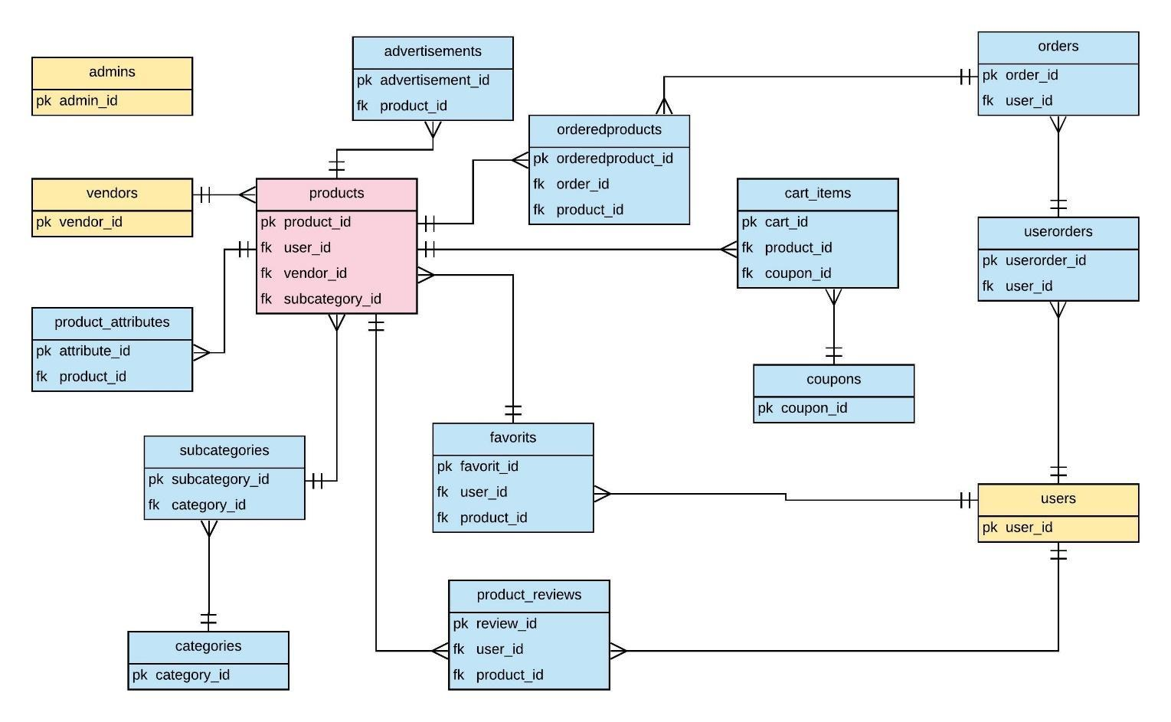

**Use Cases**

* **User Module**

**1. Search Products**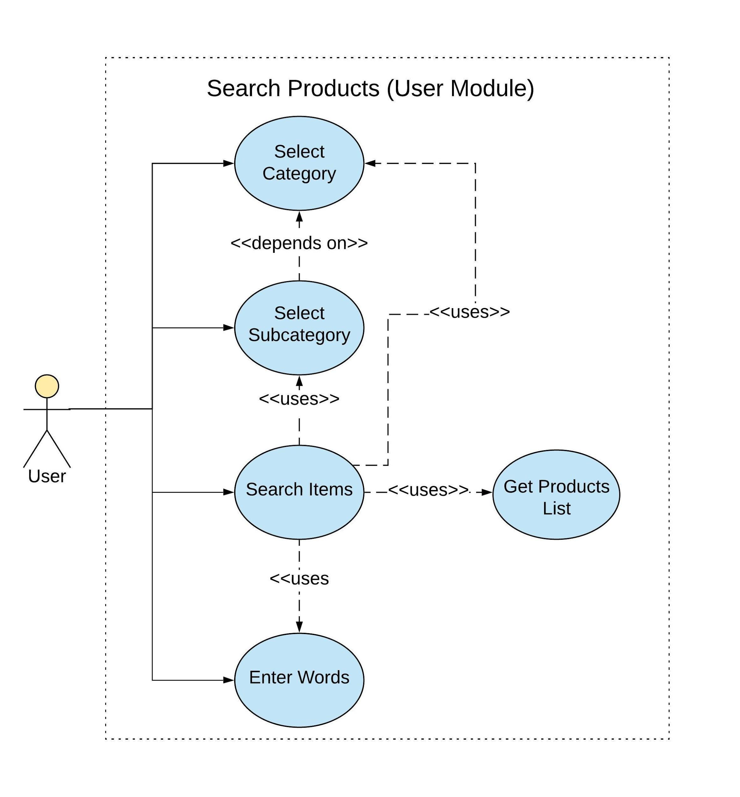

**2. Order Products**

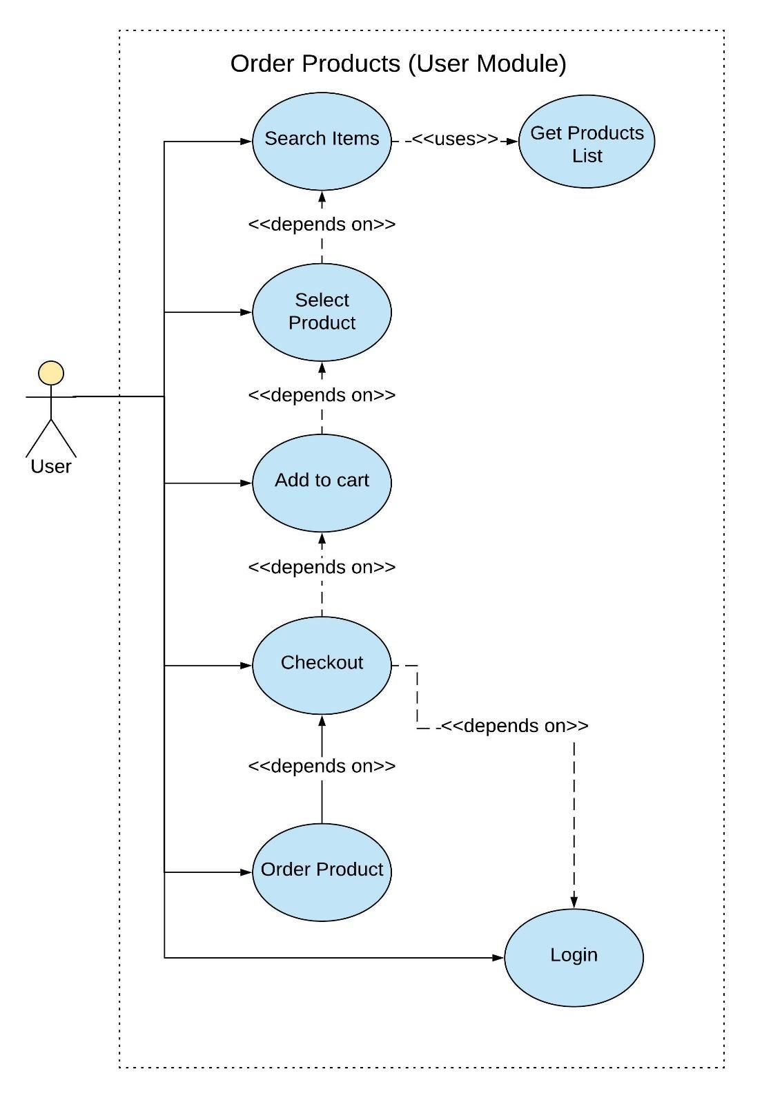

**3. Review of Products**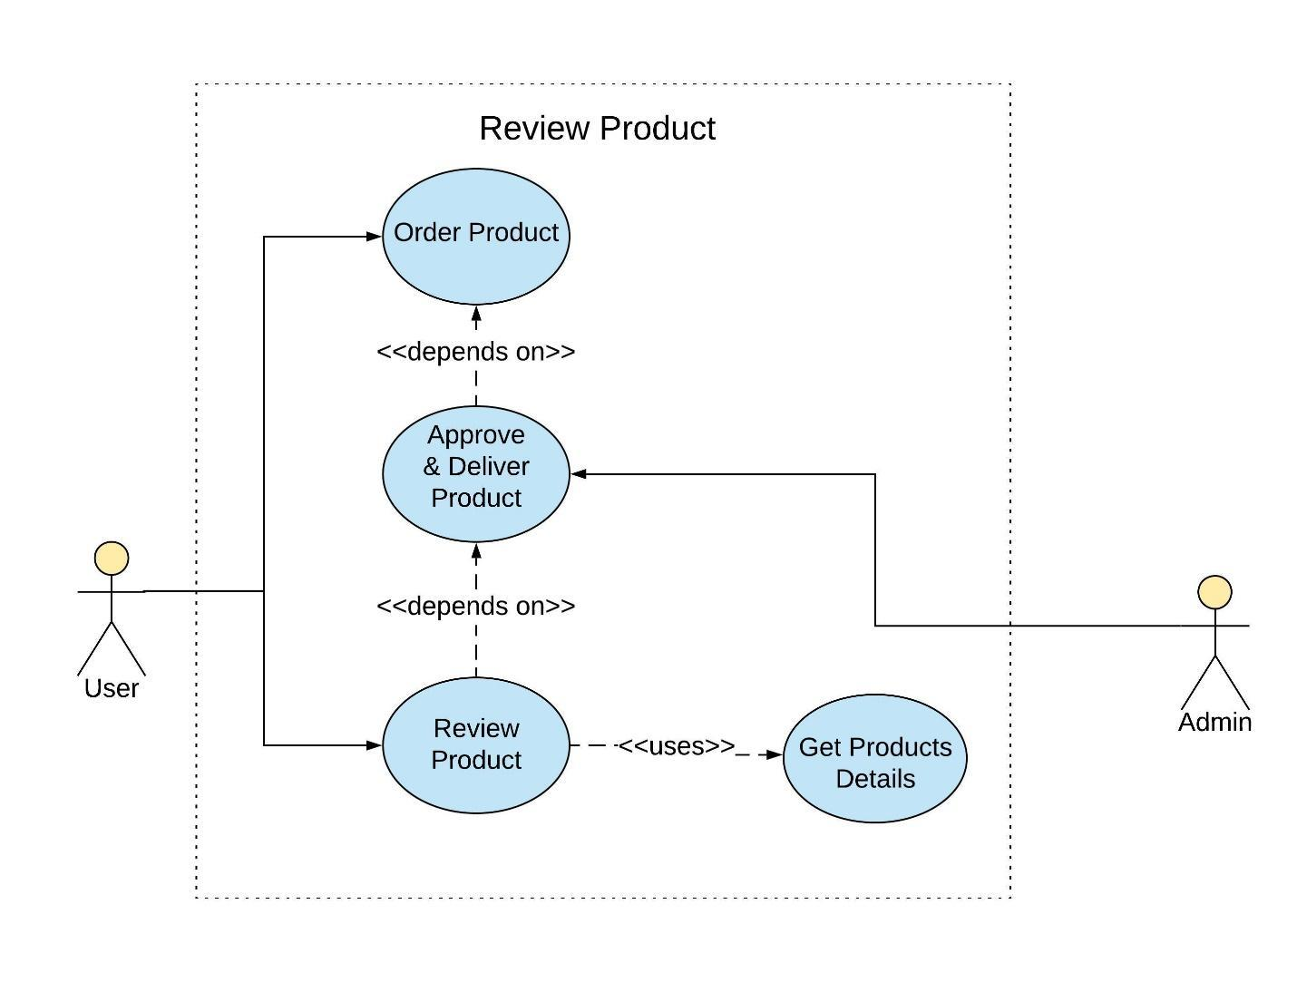

* **Vendor Module**

**1. Add Products**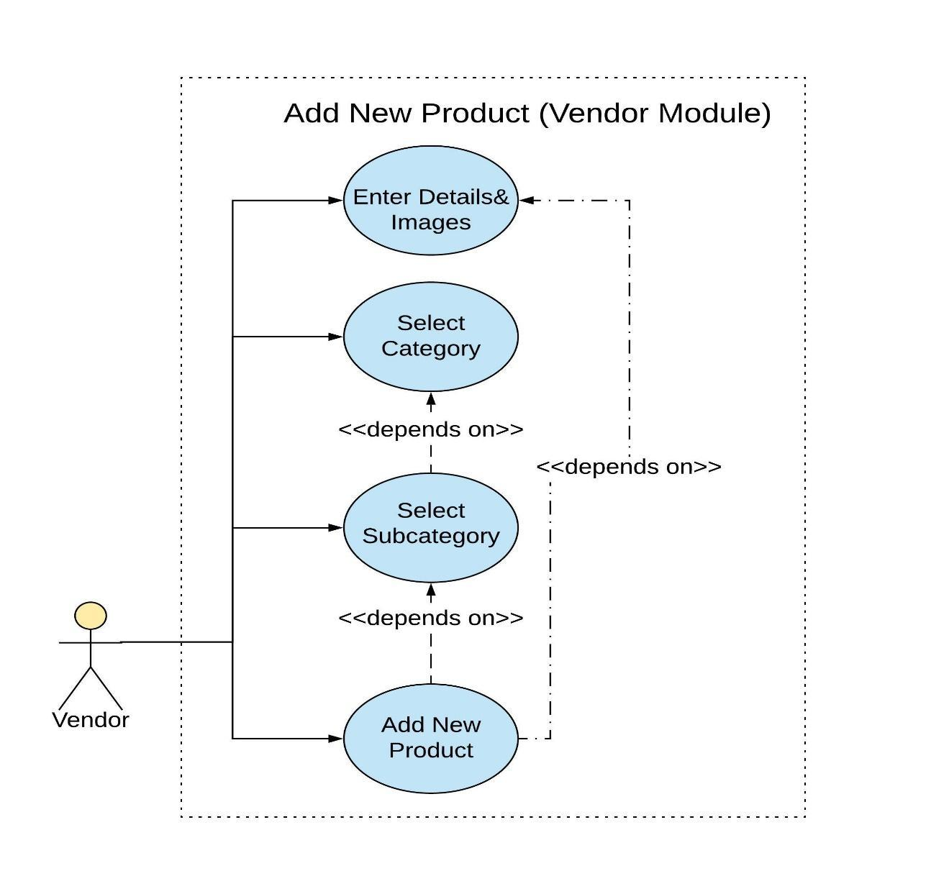

* **Admin Module**

**1. Category & Subcategory Management**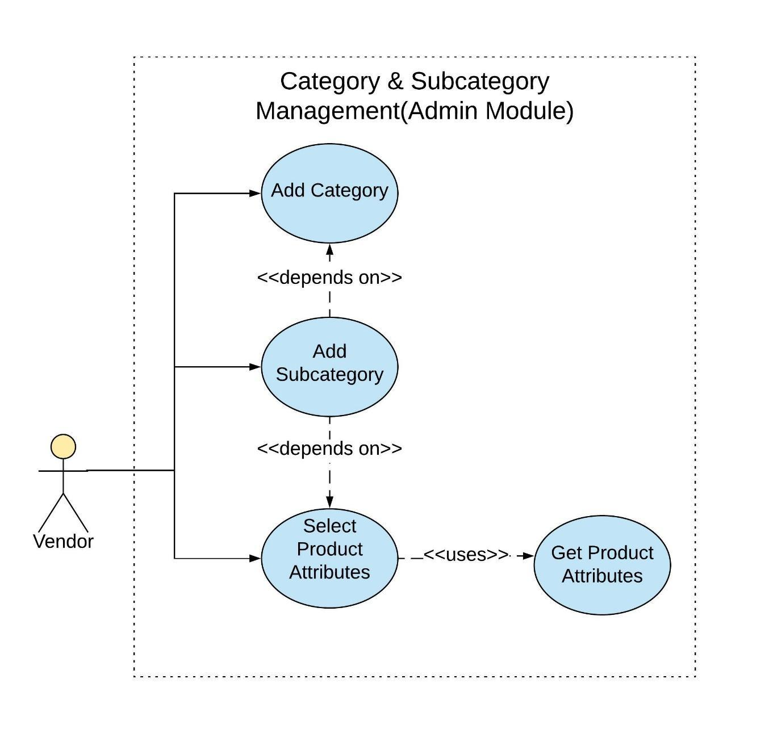

**2. Order Management**

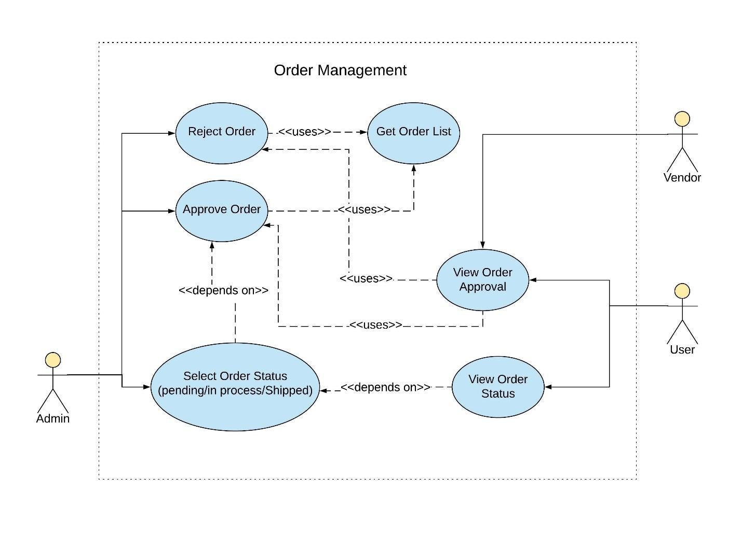

**Sequence Diagrams**

**1. Search Products**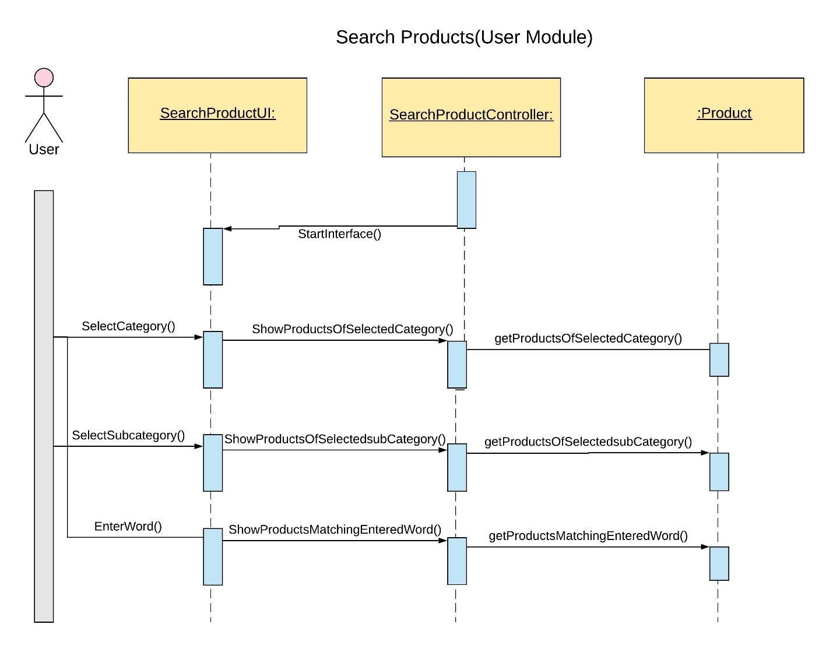

**2. Review Products**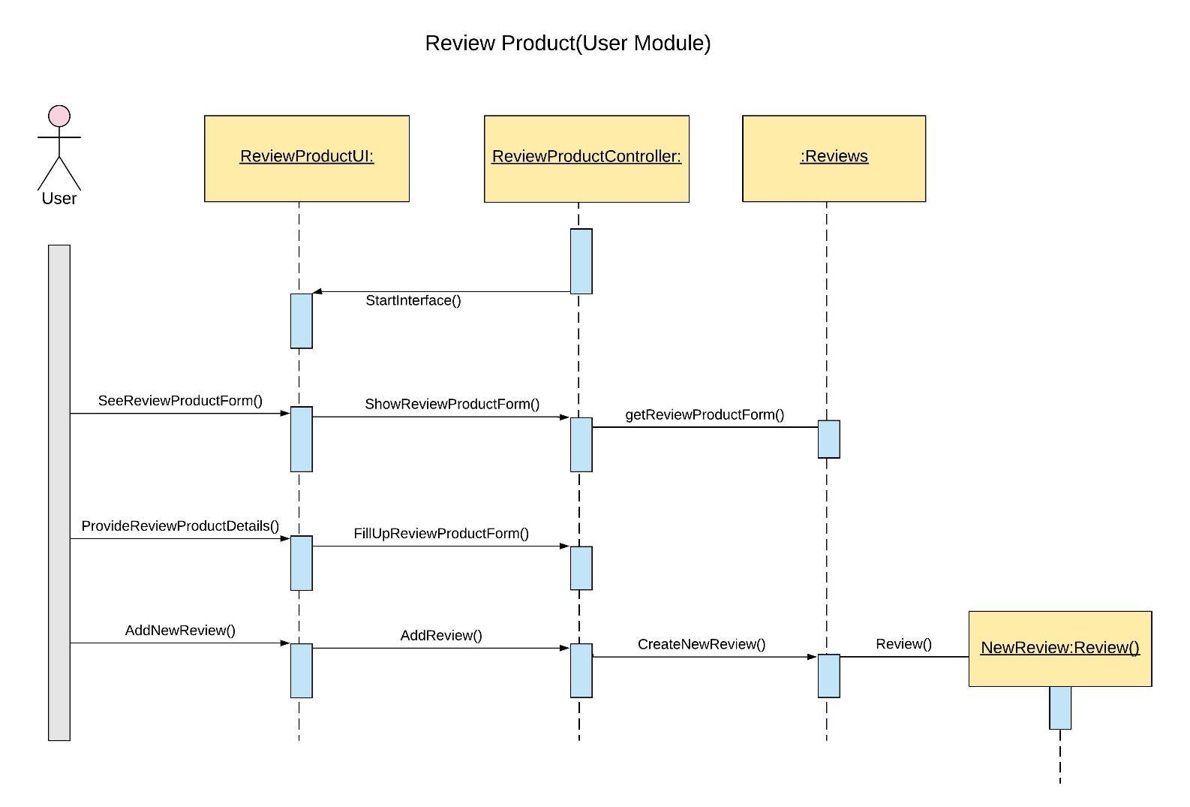

**3. Add Products** 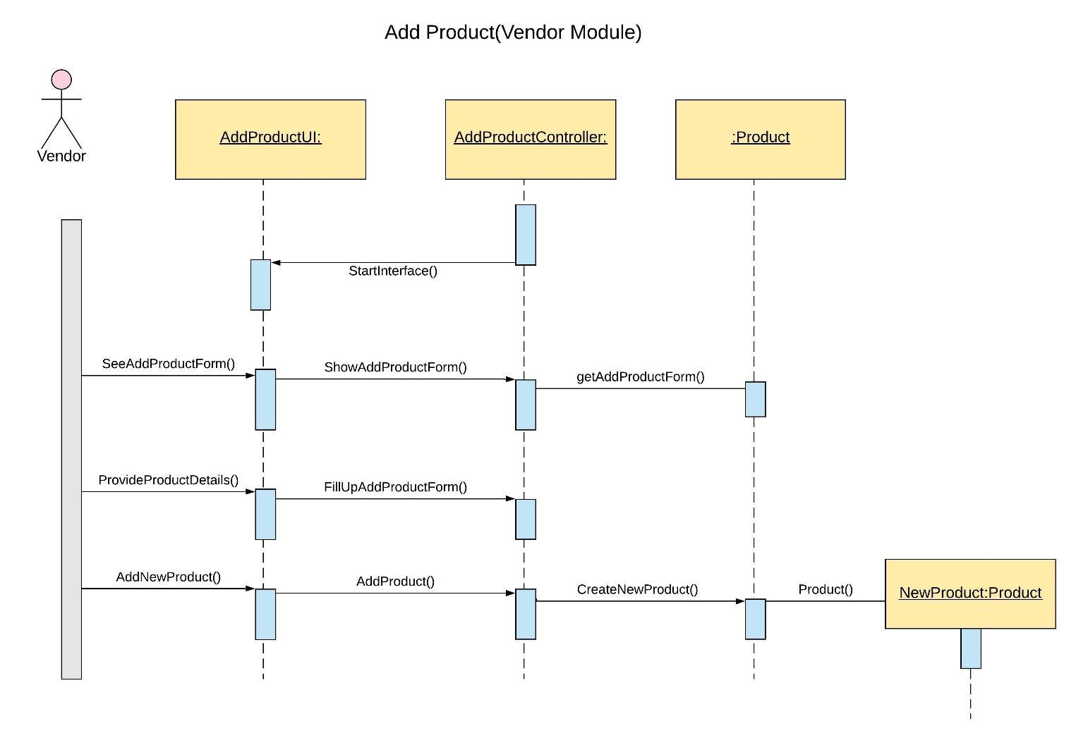

**4. Add Category**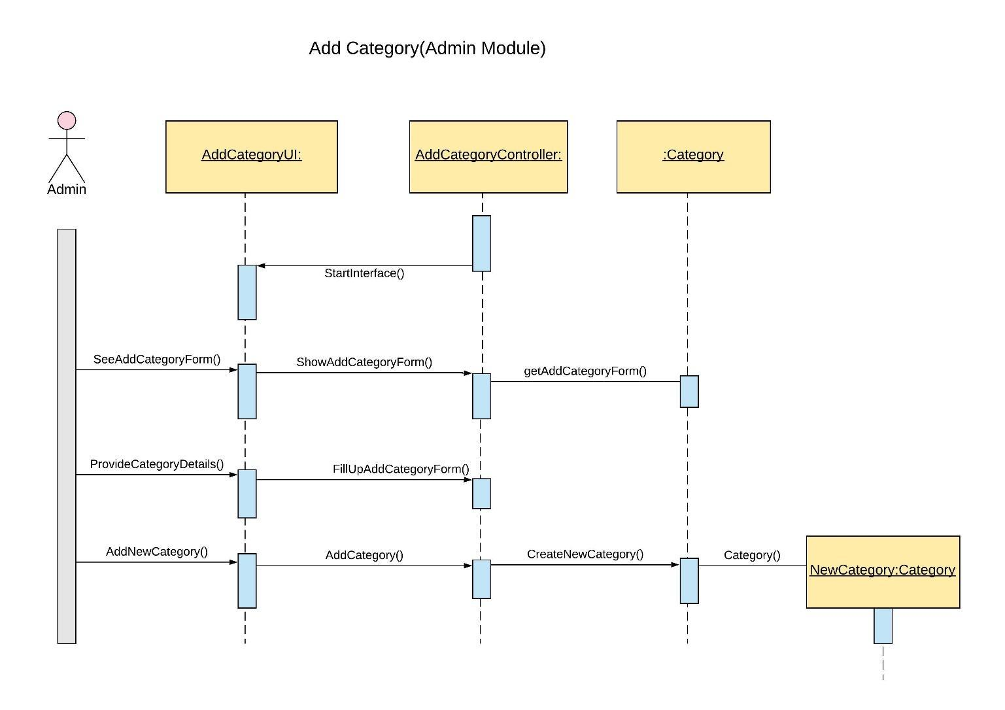

**5. Vendor Management**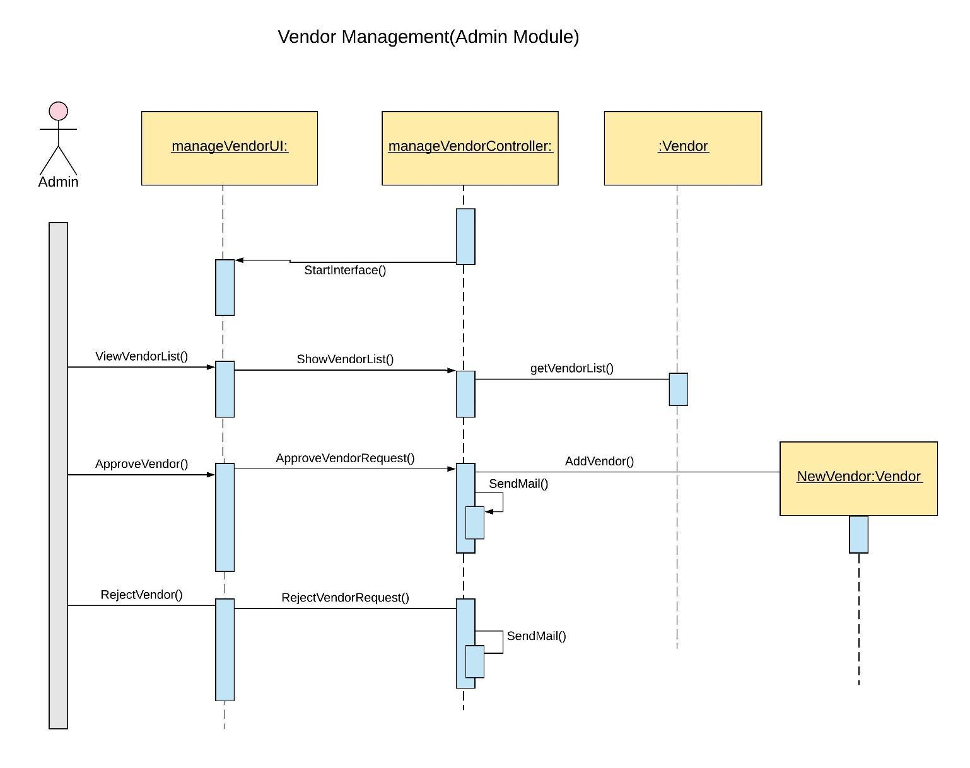

**Data Flow Diagrams**

**1. Order Product**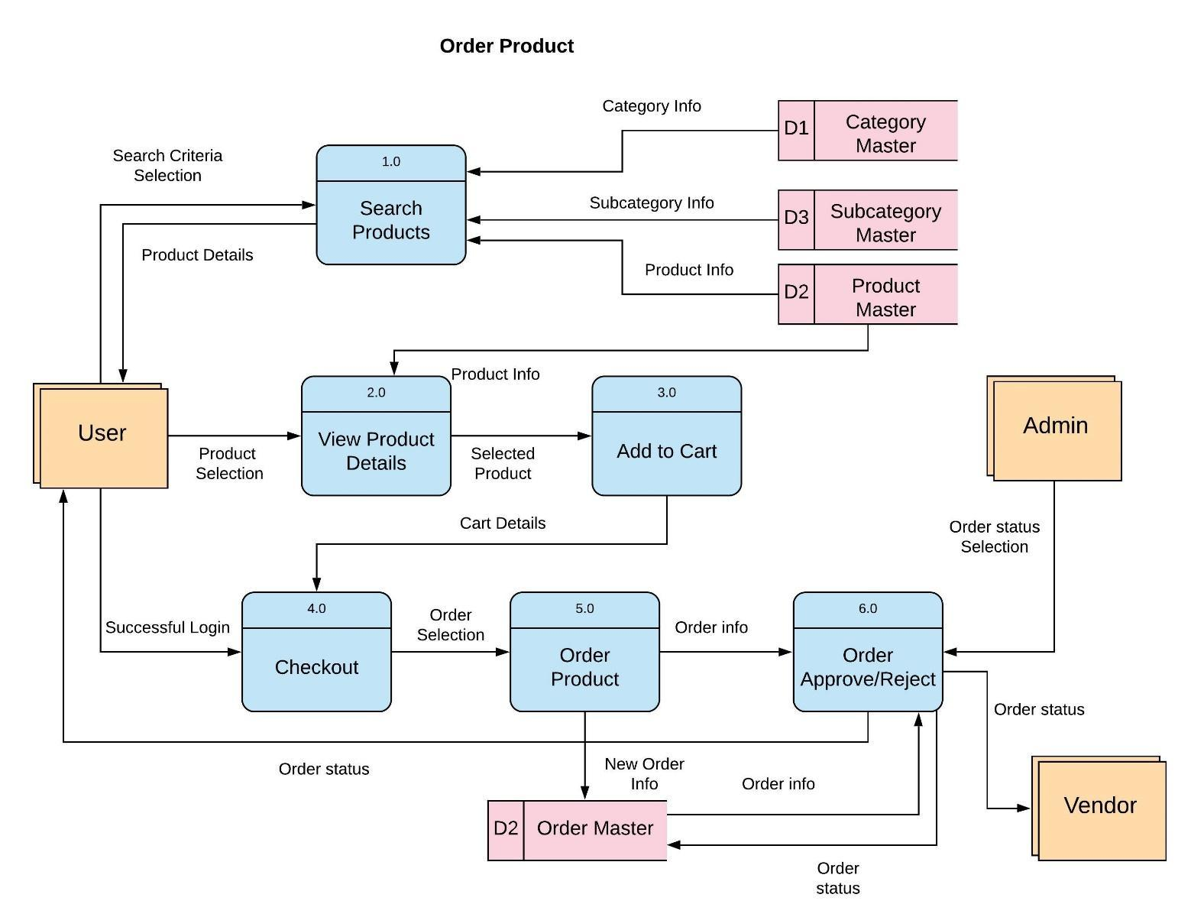

**2. Review Product**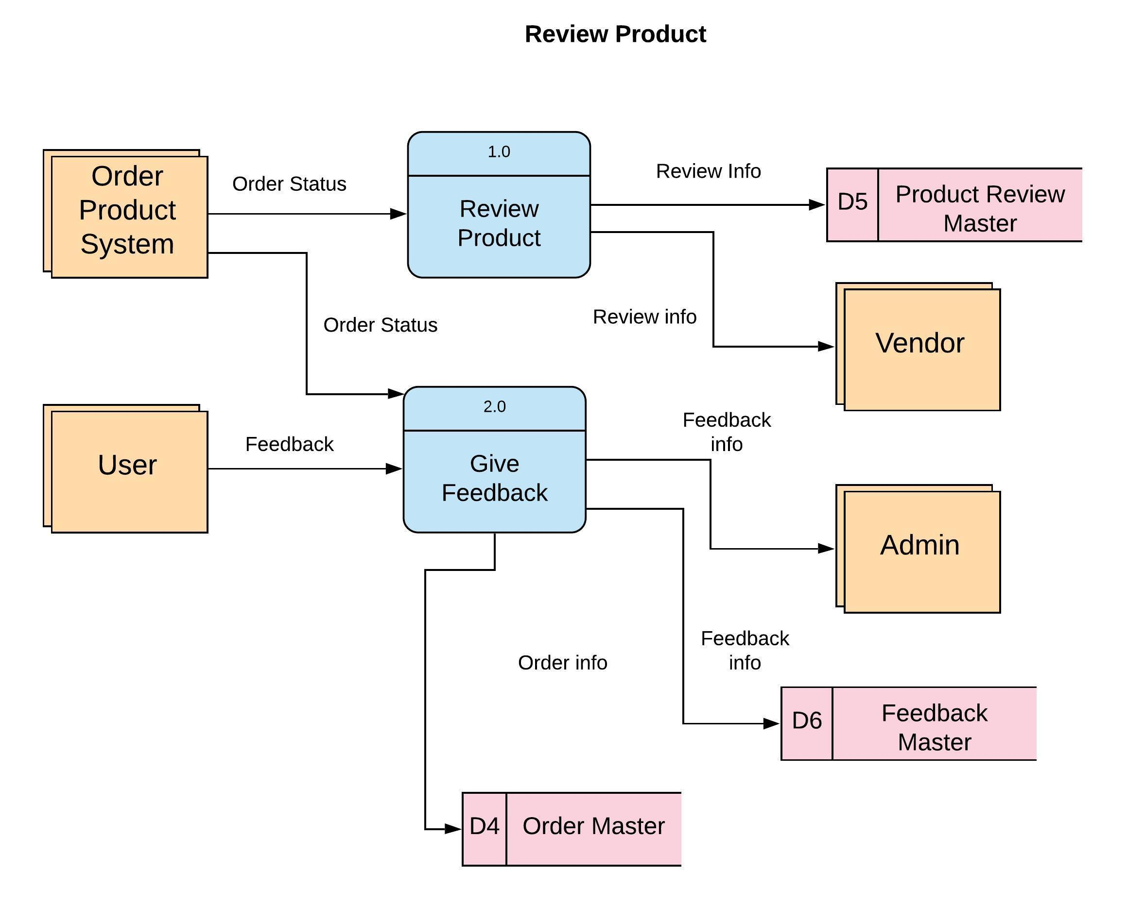

**3. Update Product**

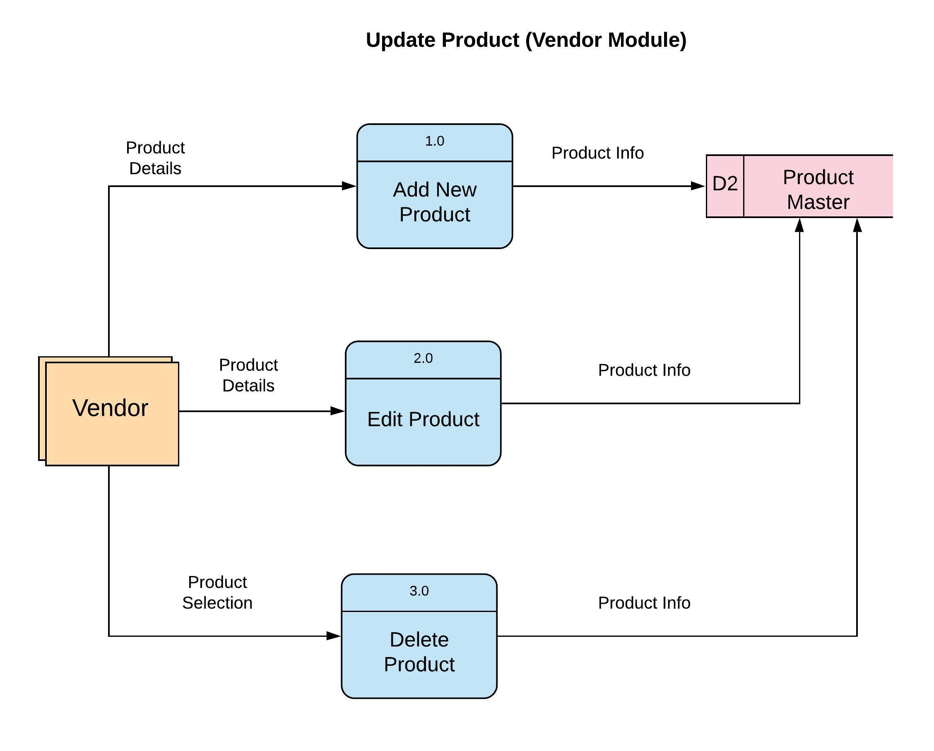

# 

# User Guide

**Admin Module Guide:**

**Login:**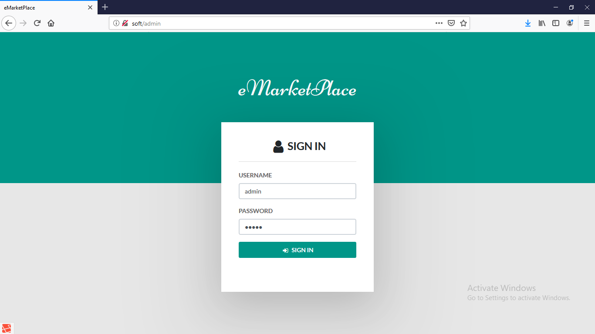

**Dashboard:**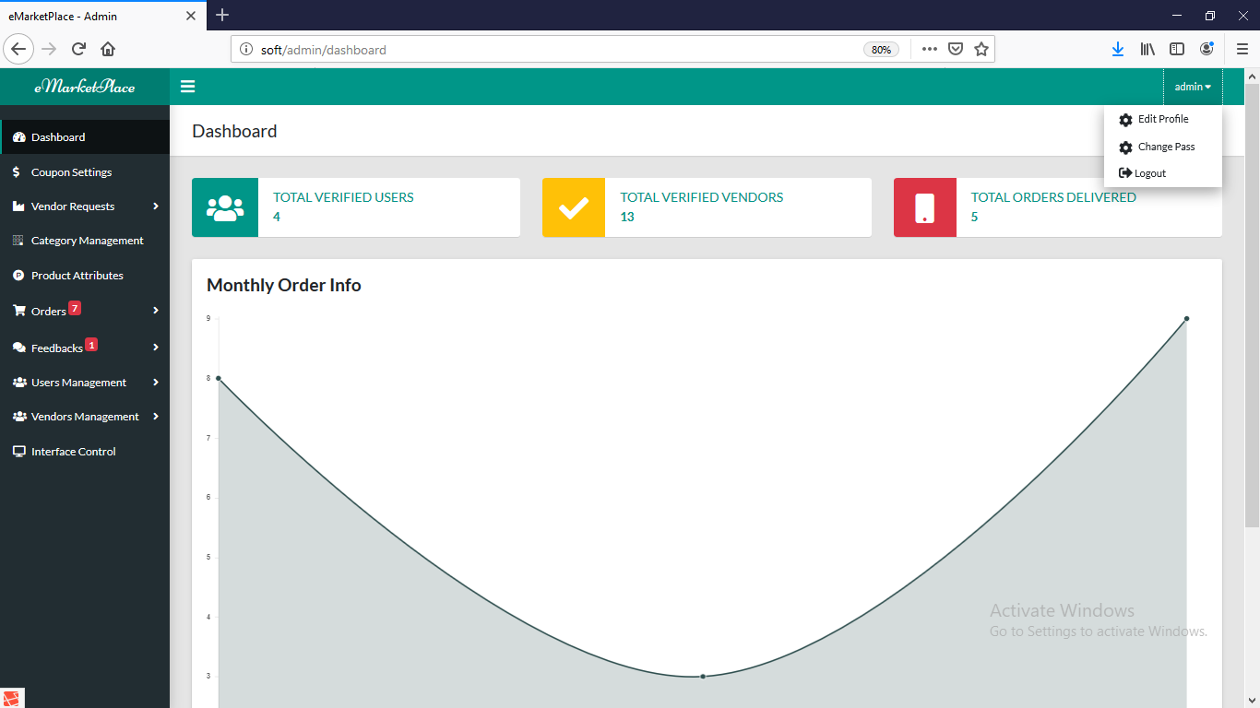

**Vendor Request Management:**

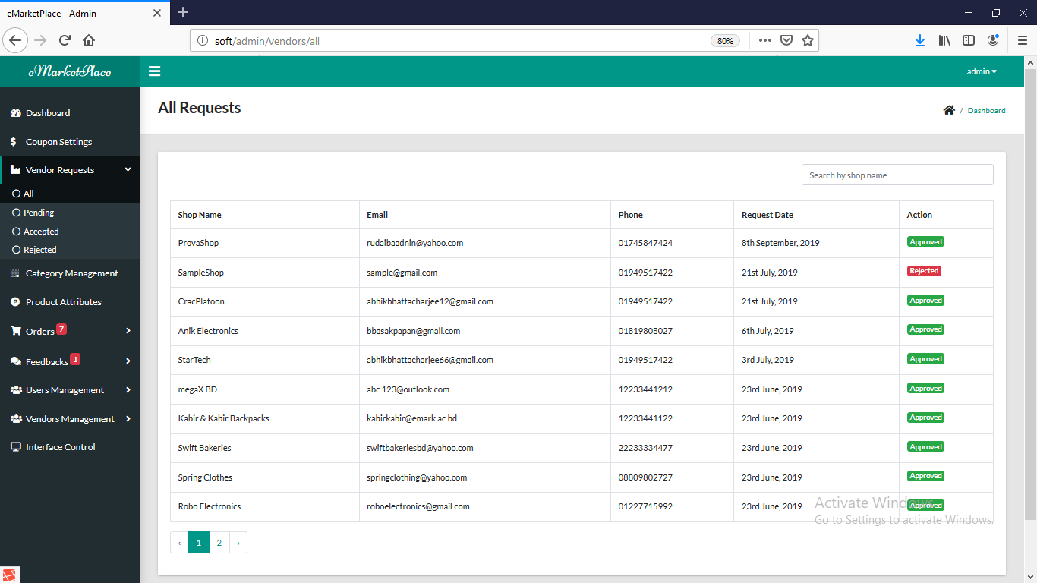

**Category Management:**

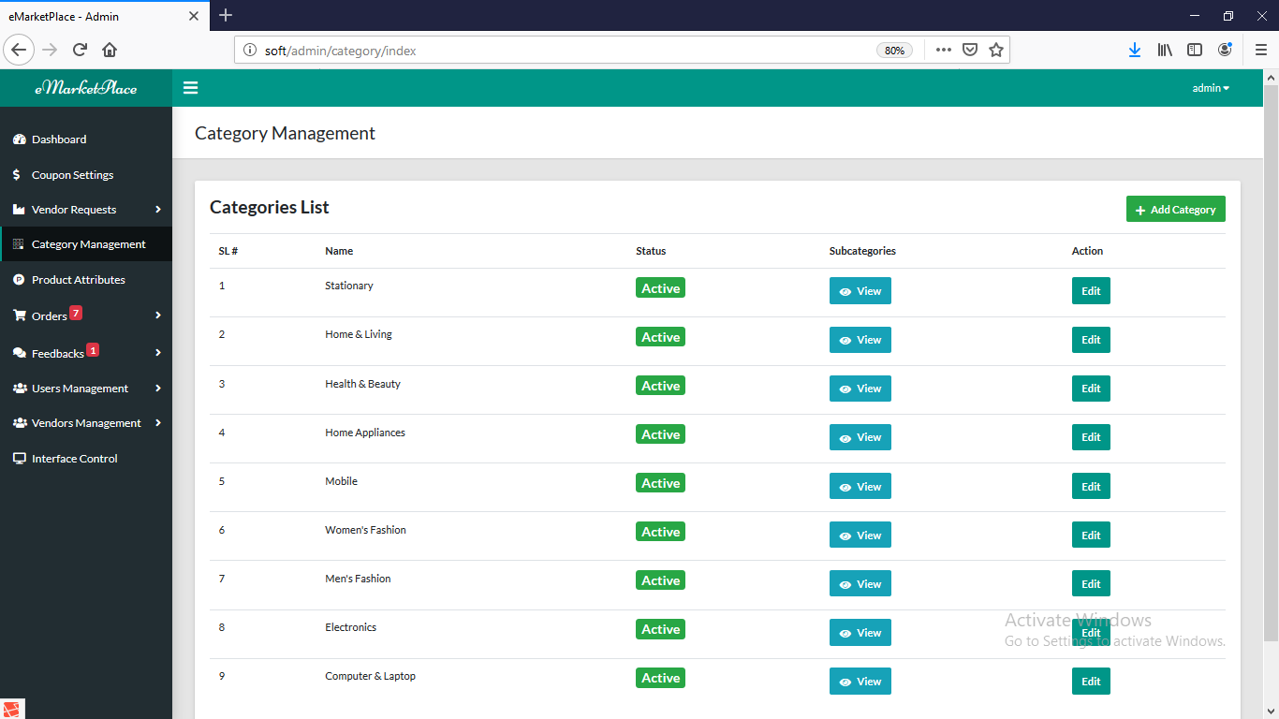

**Product Attributes Management:**

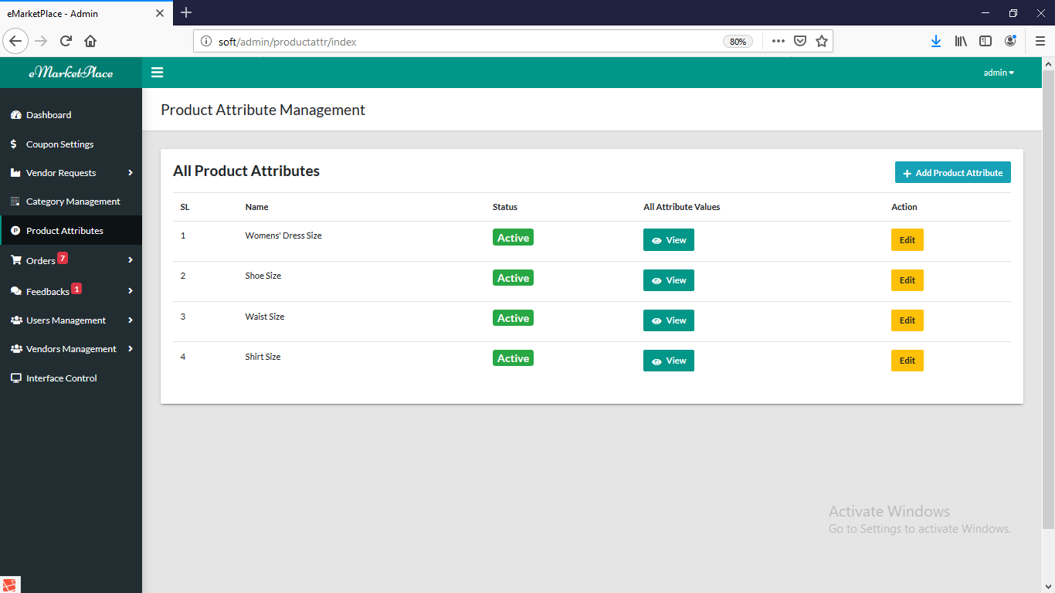

**Order Management:**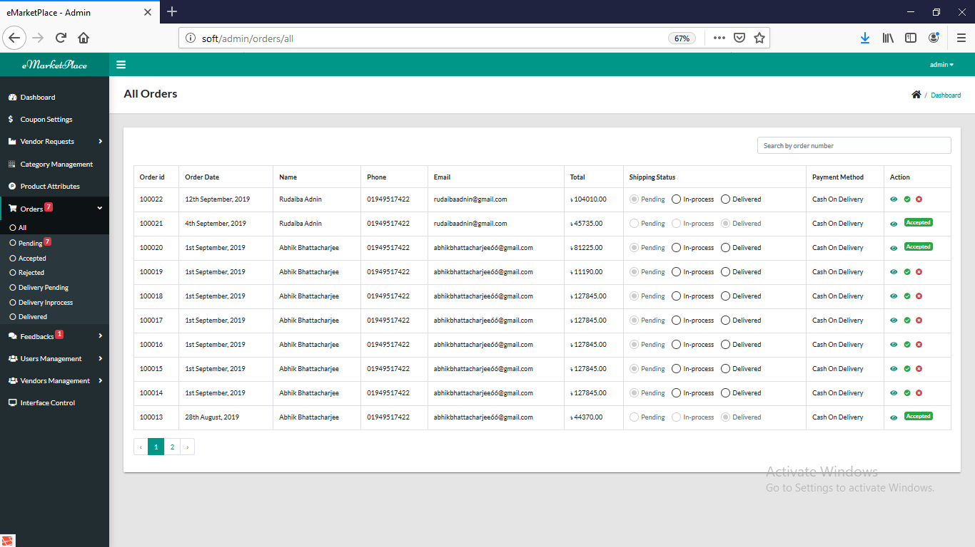

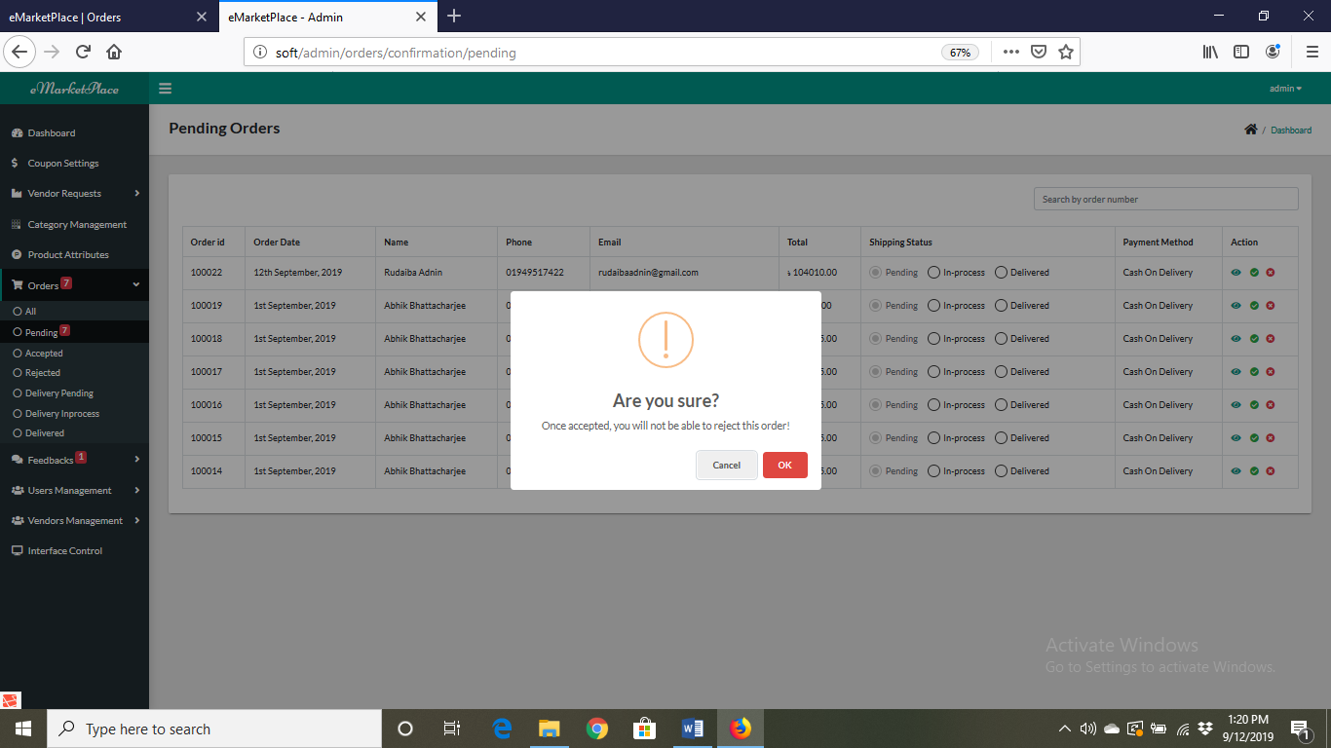

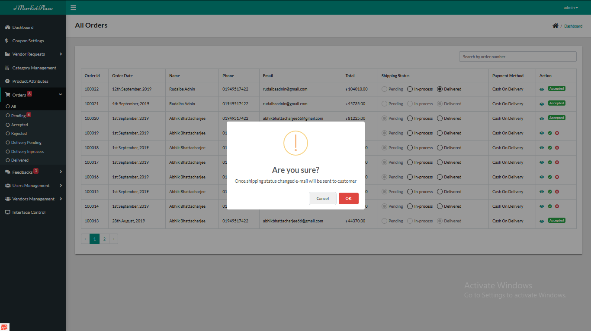

**See feedbacks:**

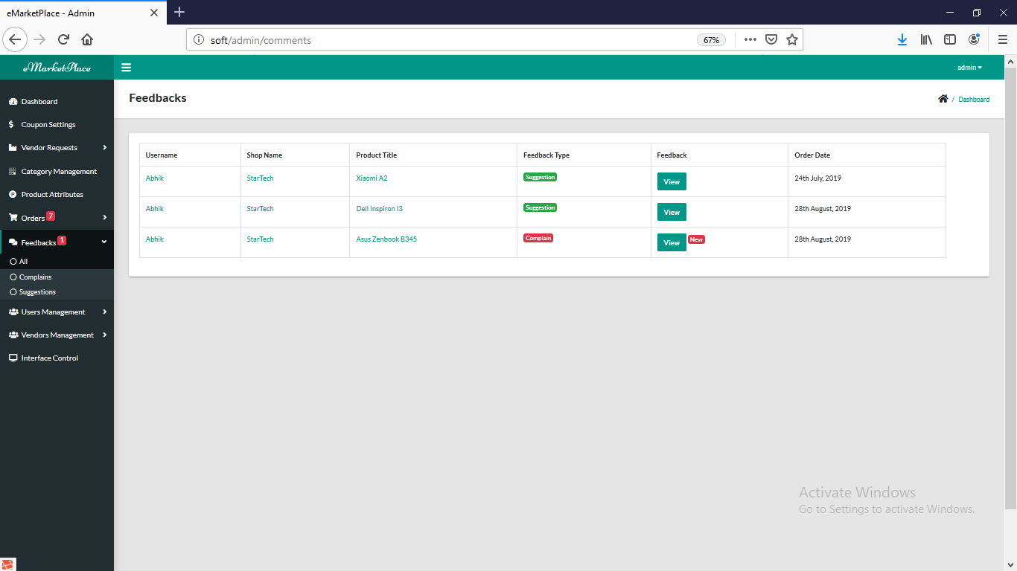

**Vendor Management:**

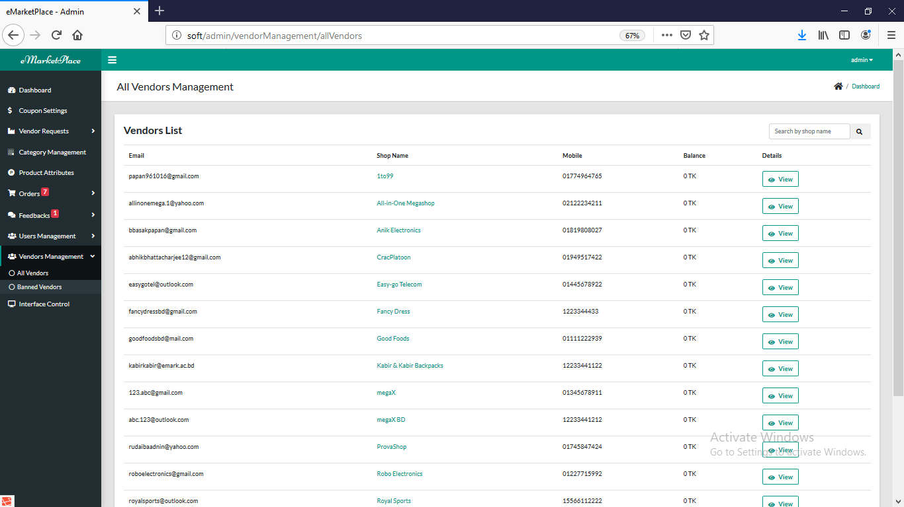

**Coupon Management:**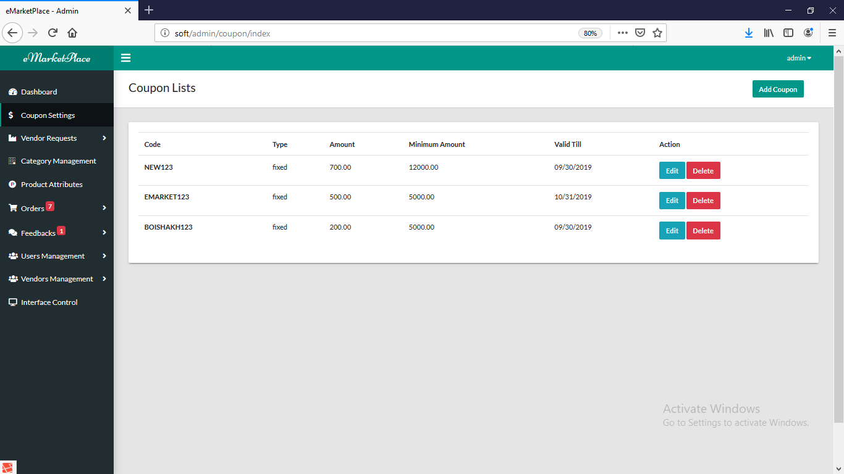

**Vendor Module Guide:**

**Login & Register:**

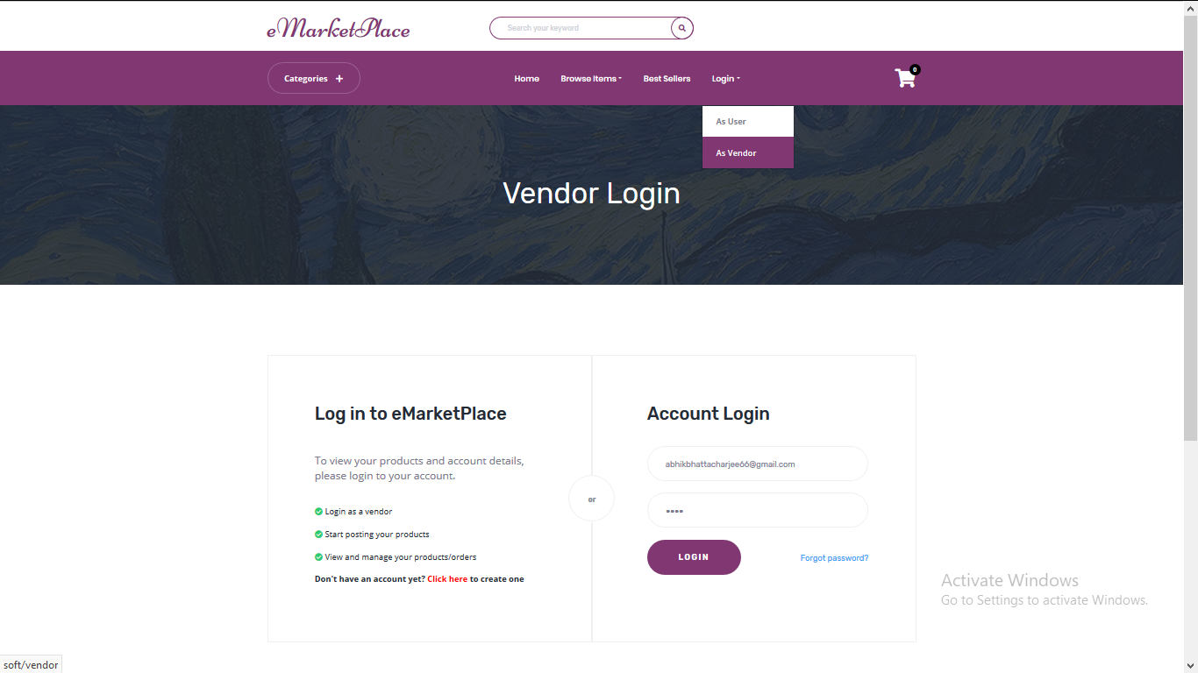

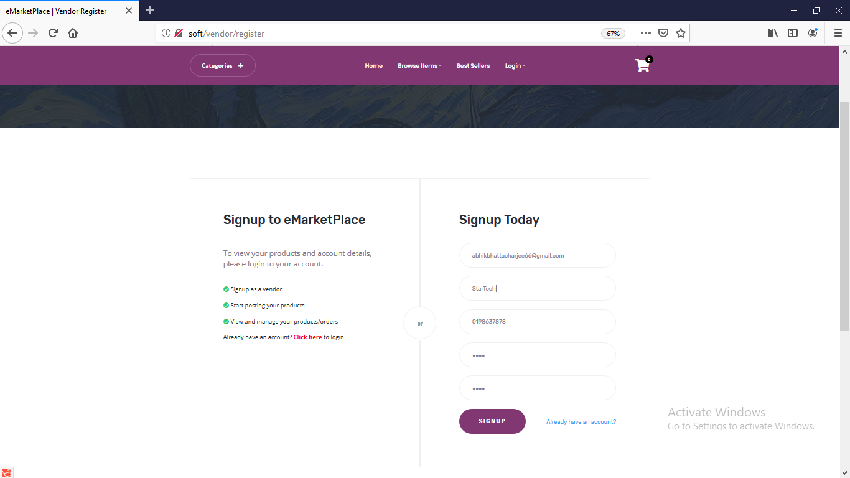

**Dashboard:**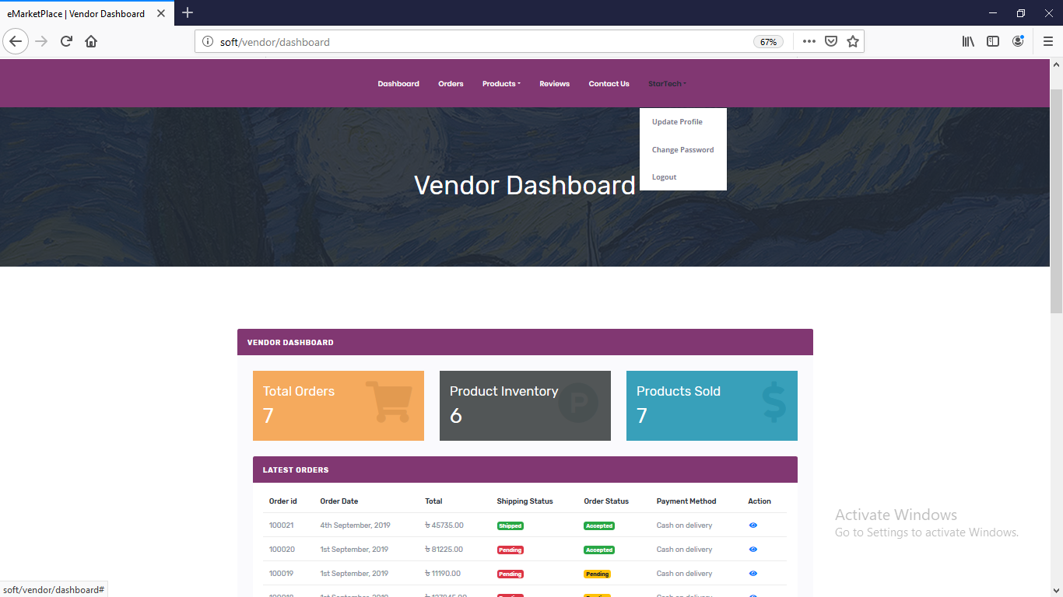

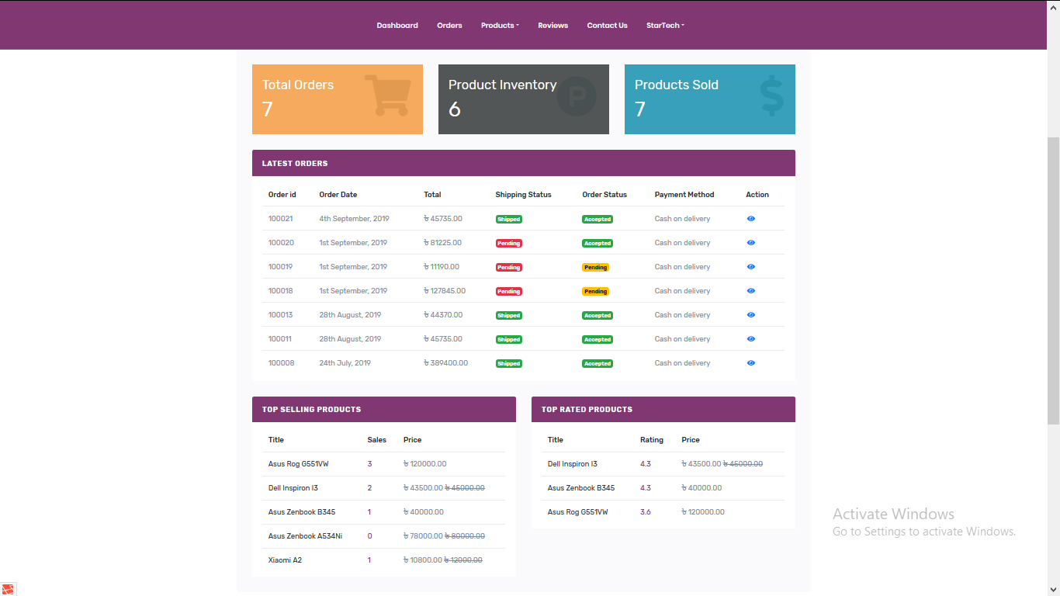

**Profile:**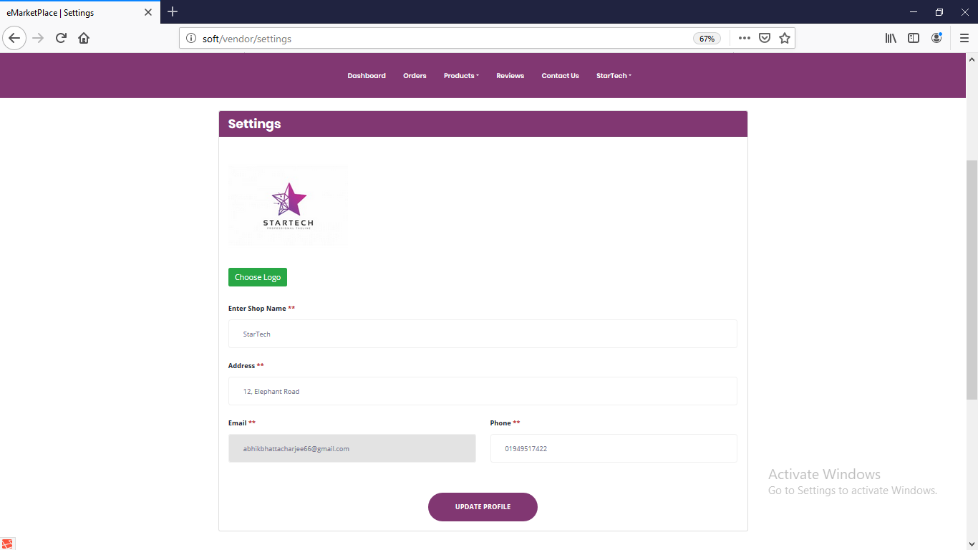

**Product Management & Update:**

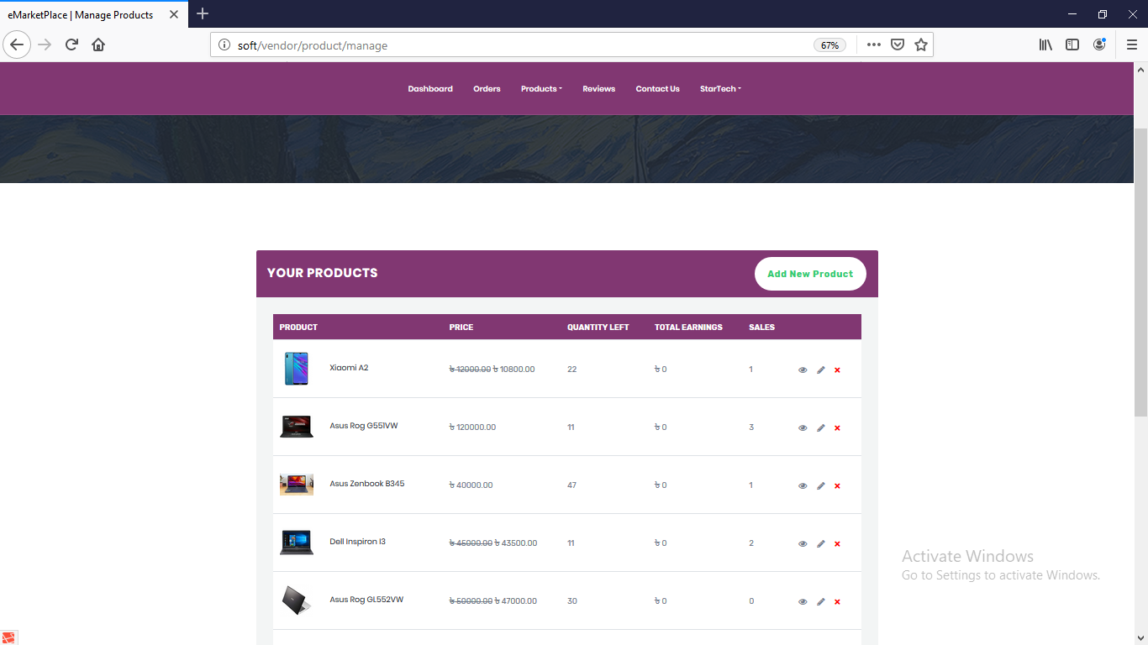

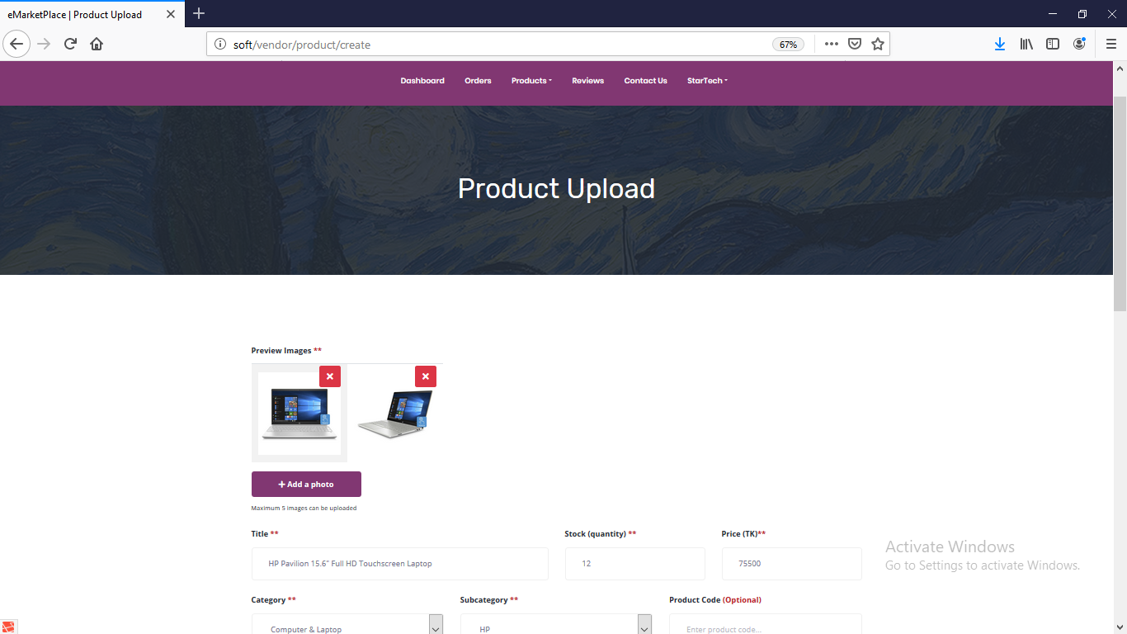

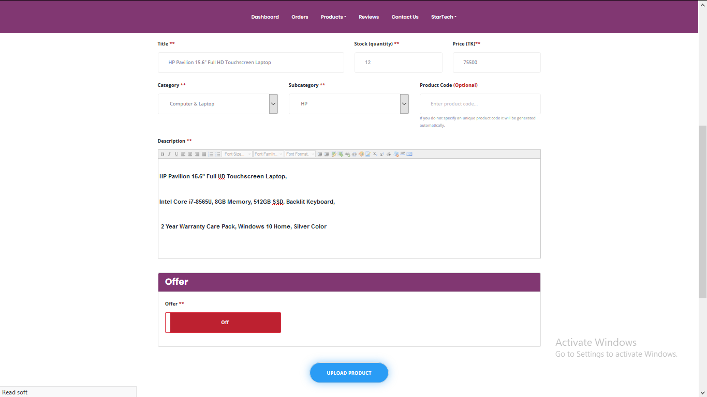

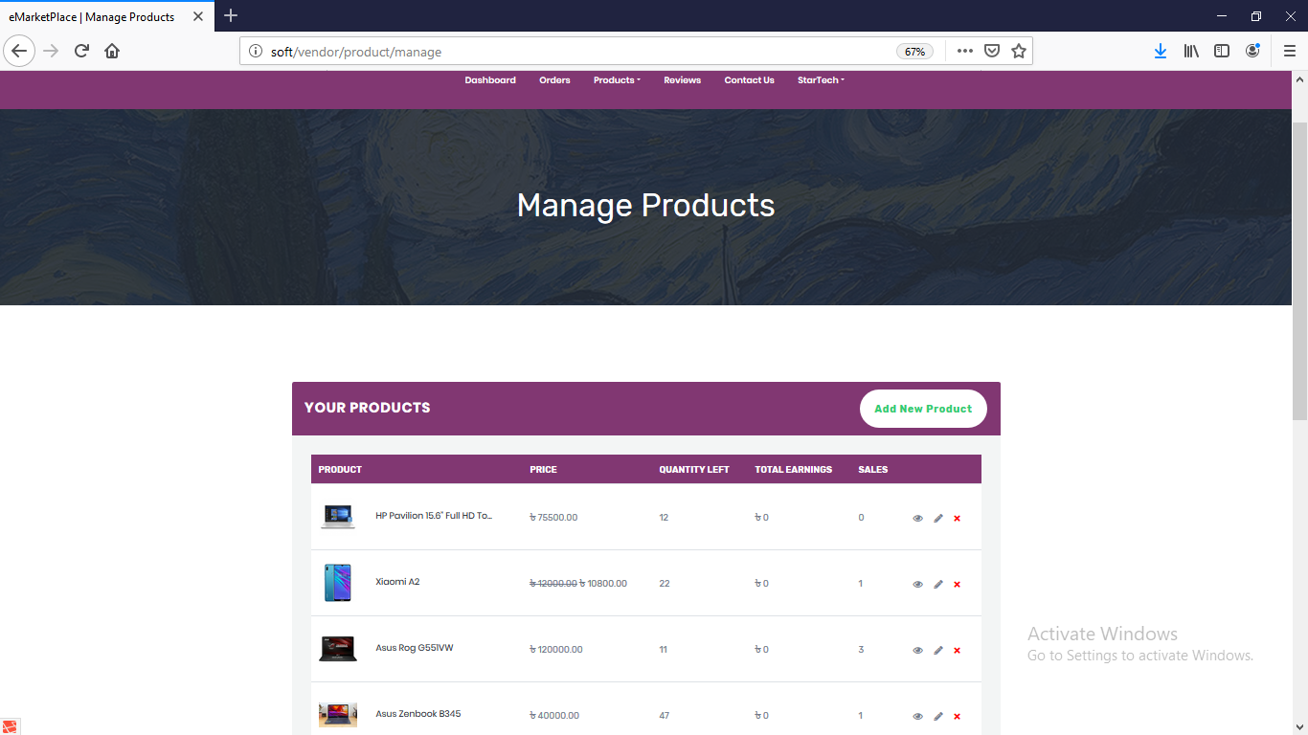

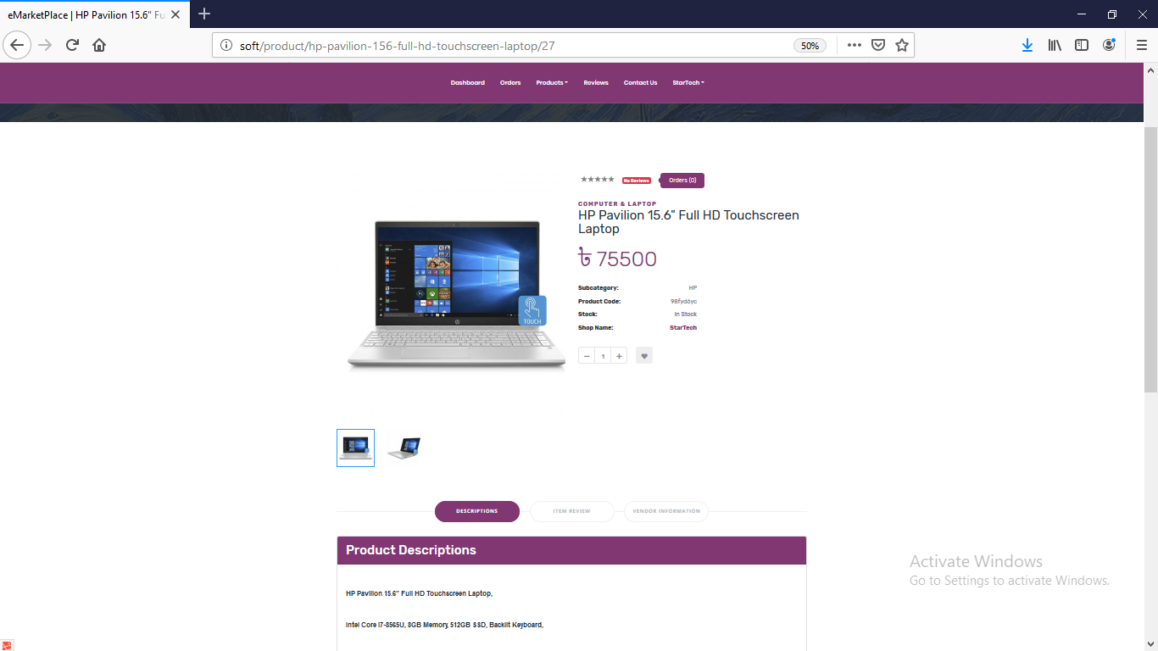

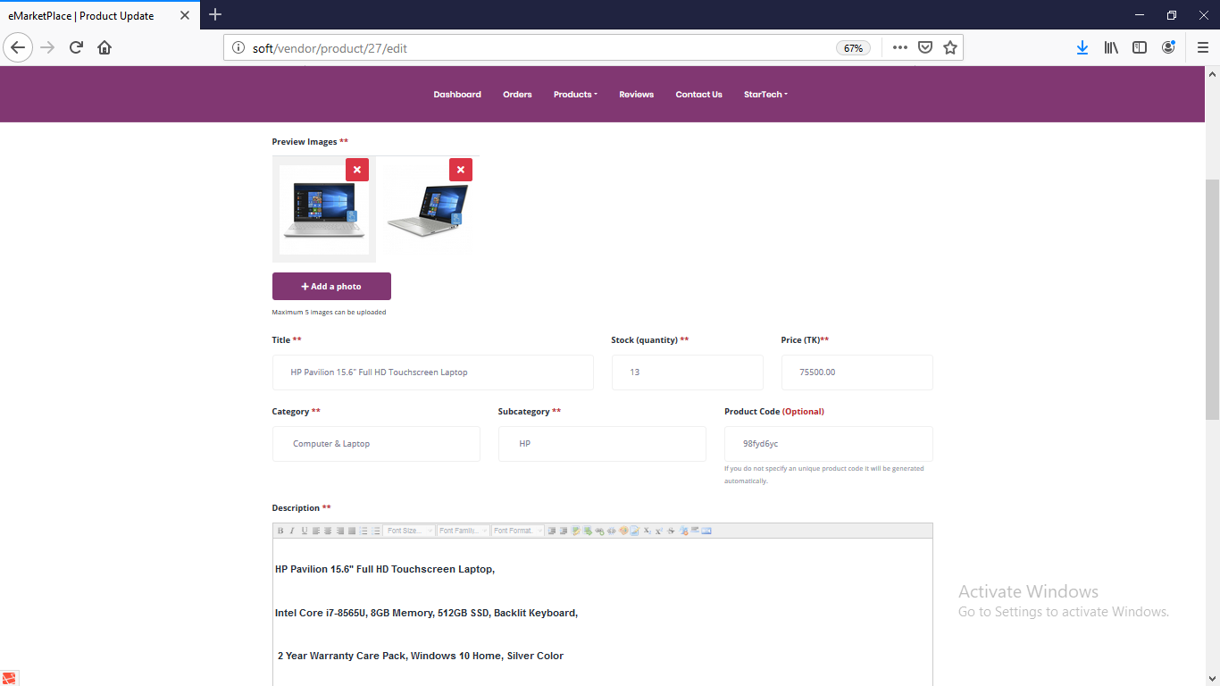

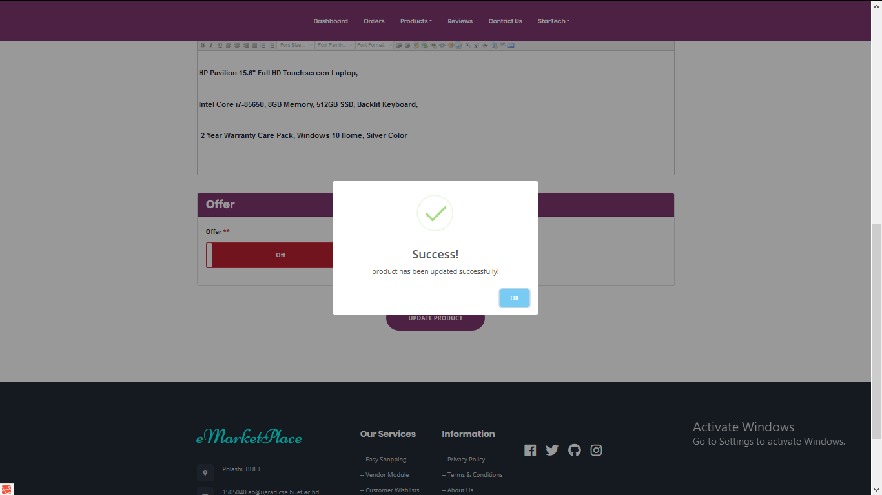

**User Module Guide:**

**Home Page:**

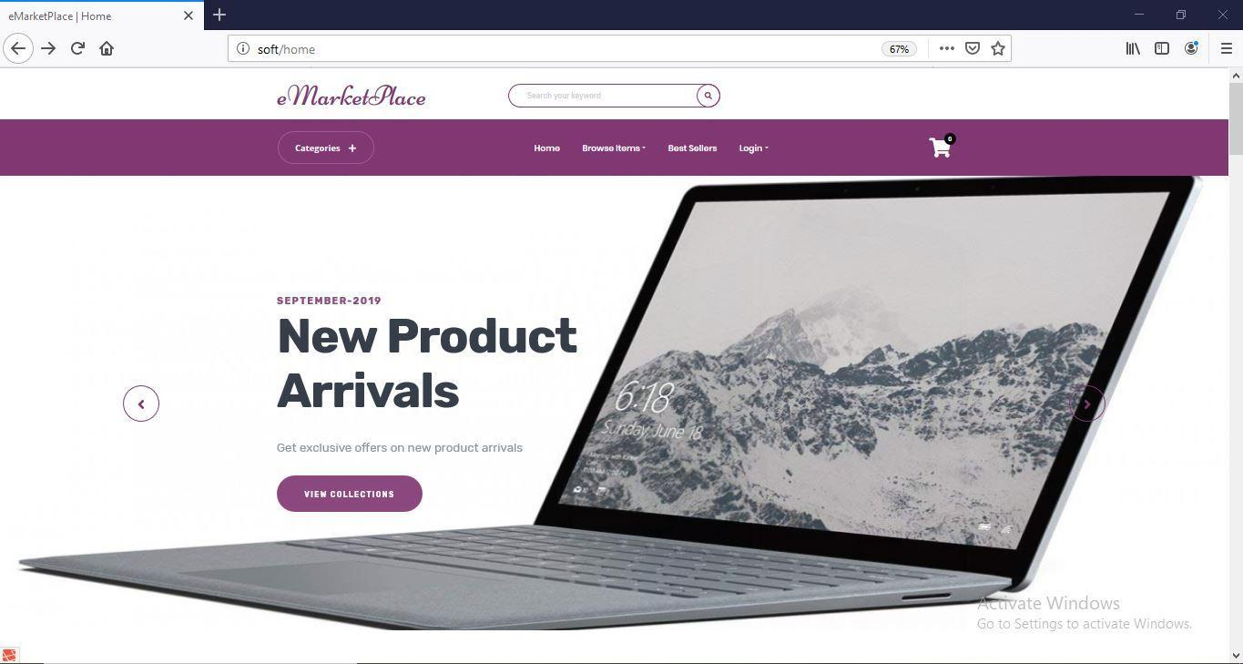

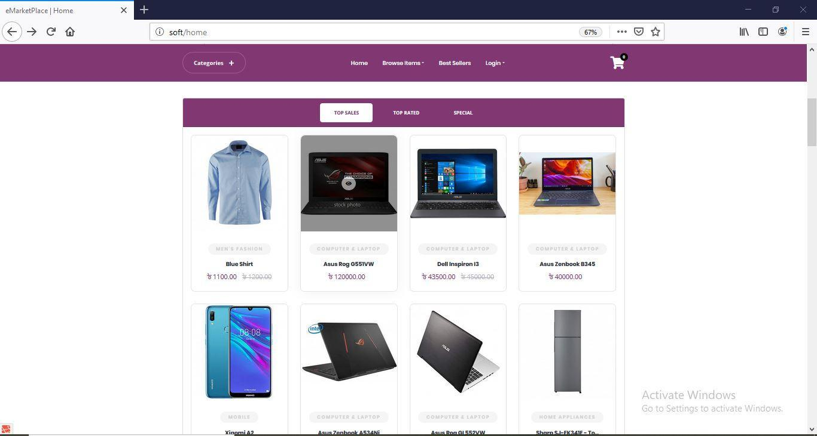

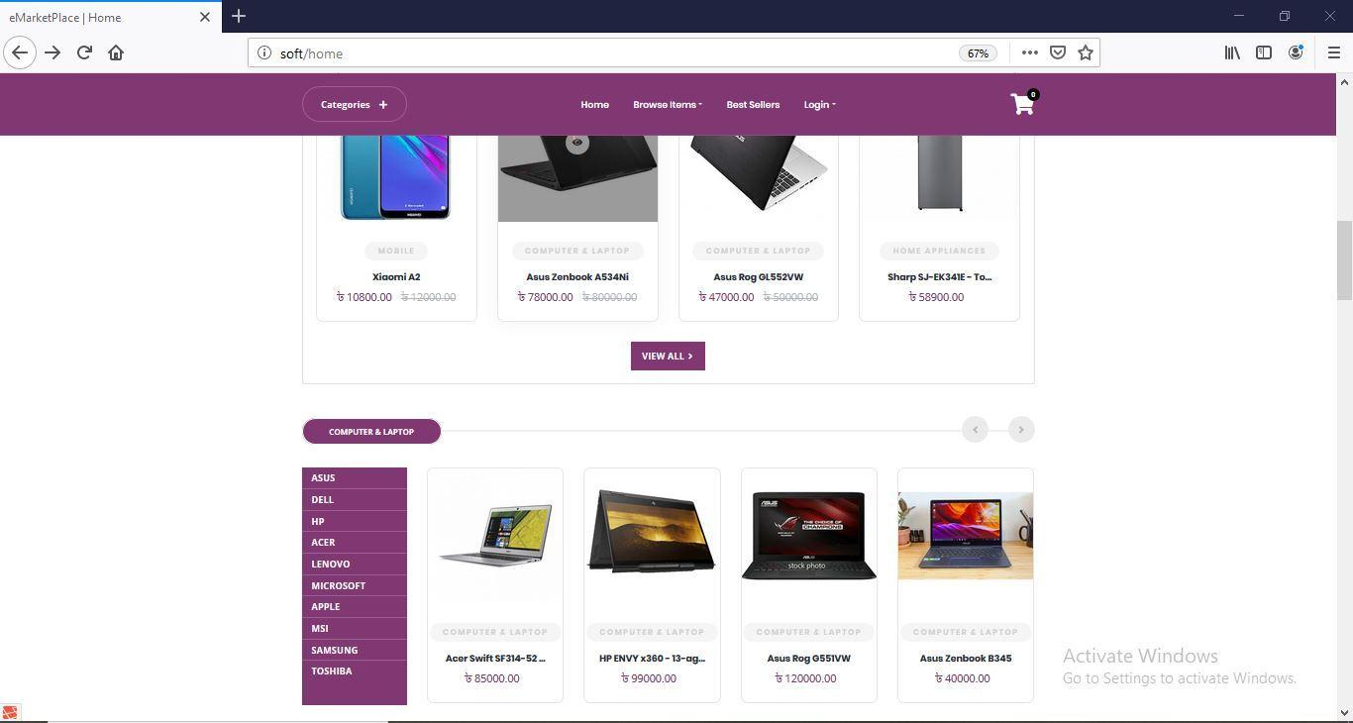

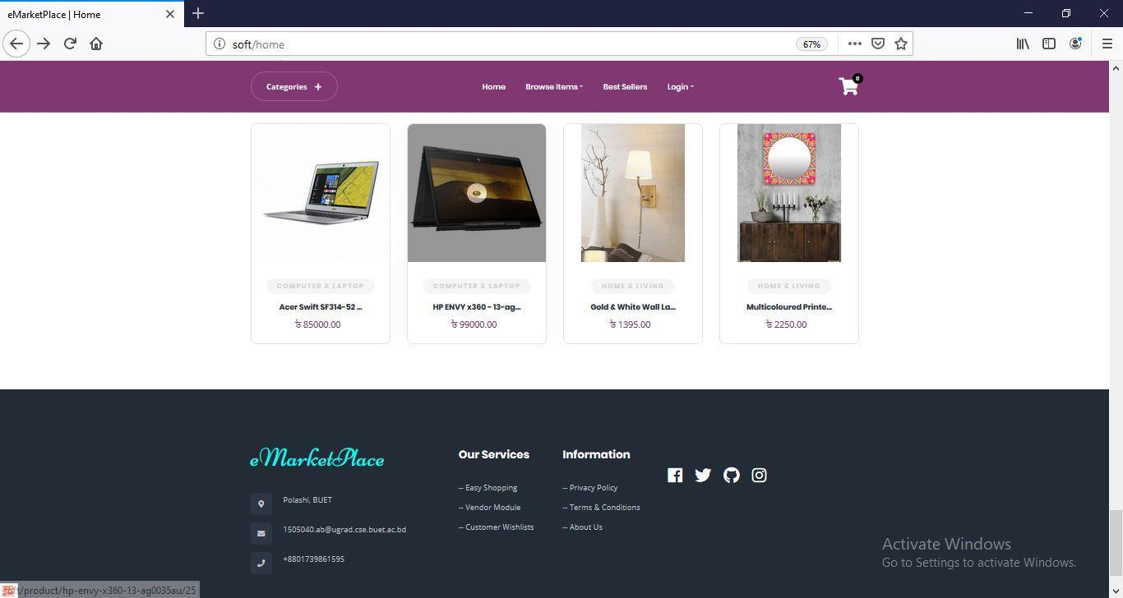

**Search in Homepage:**

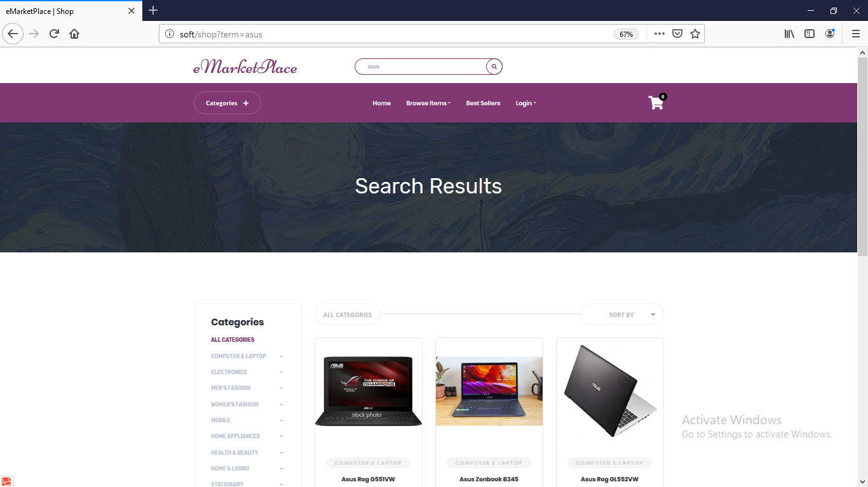

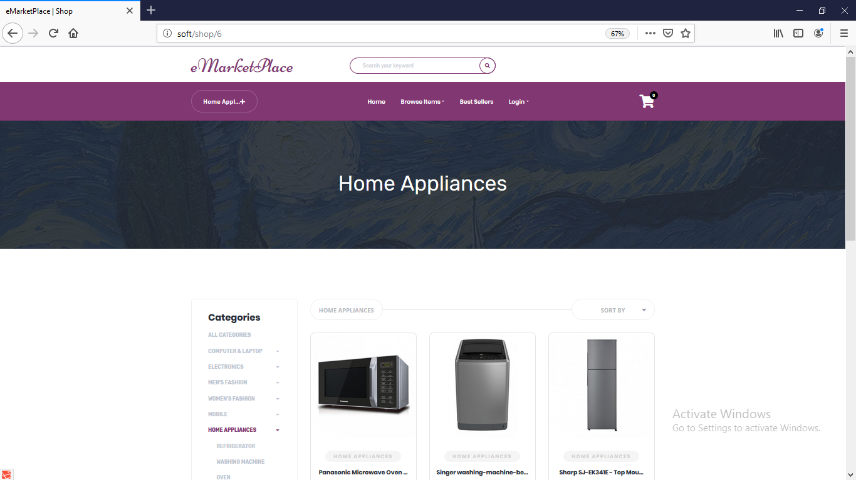

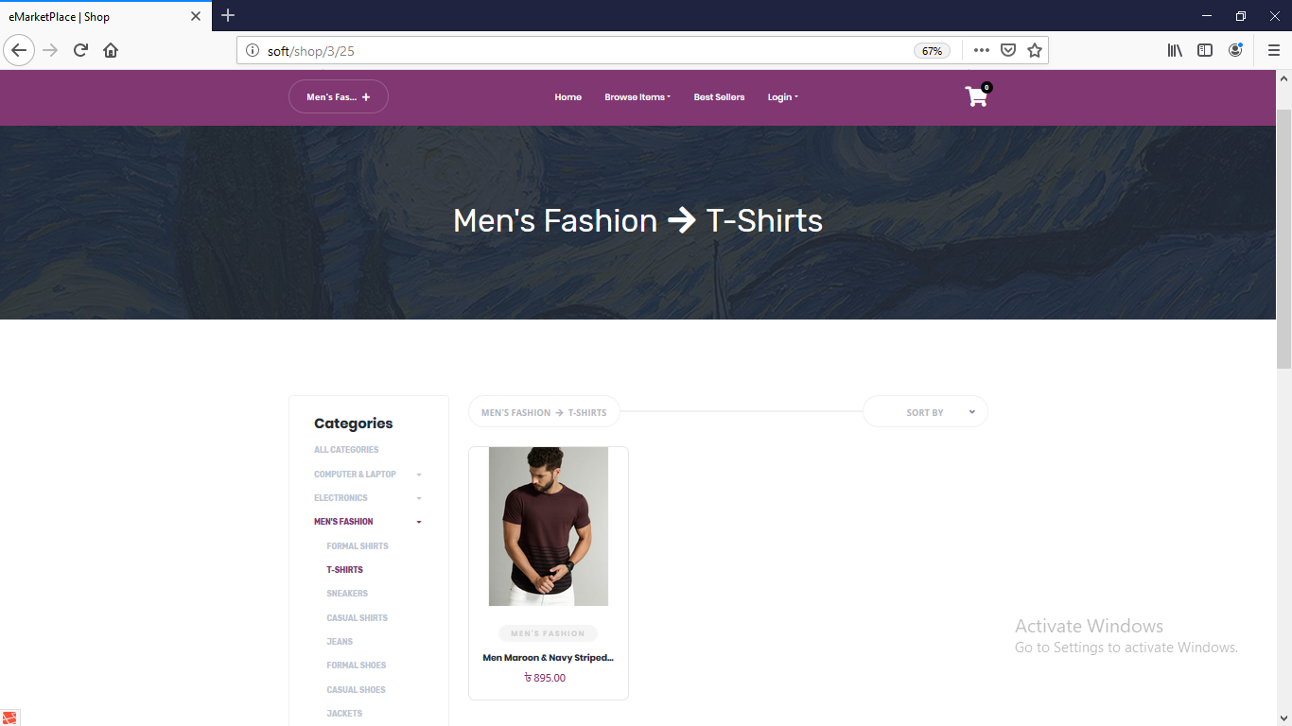

**Login and Register:**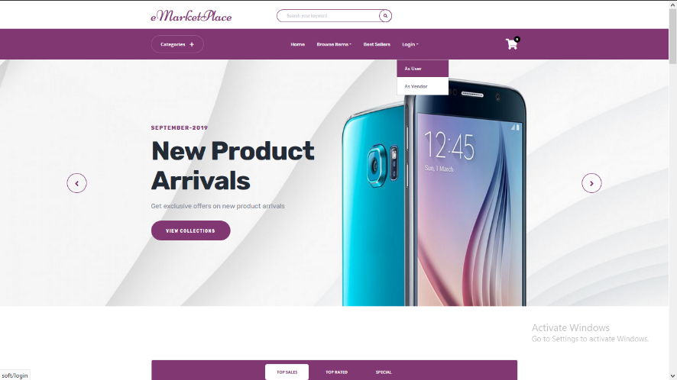

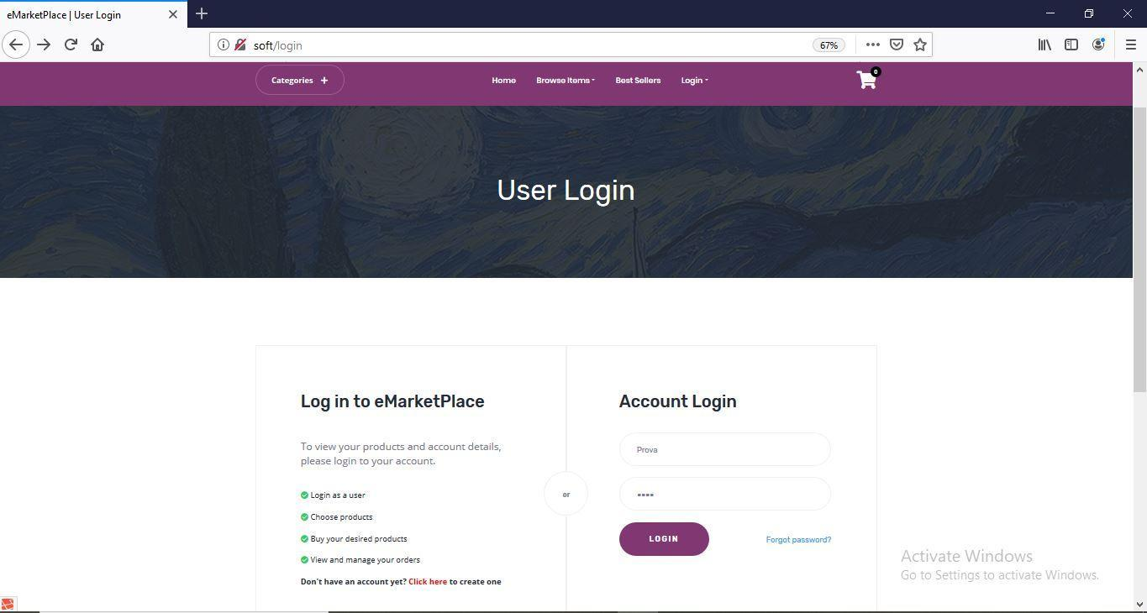

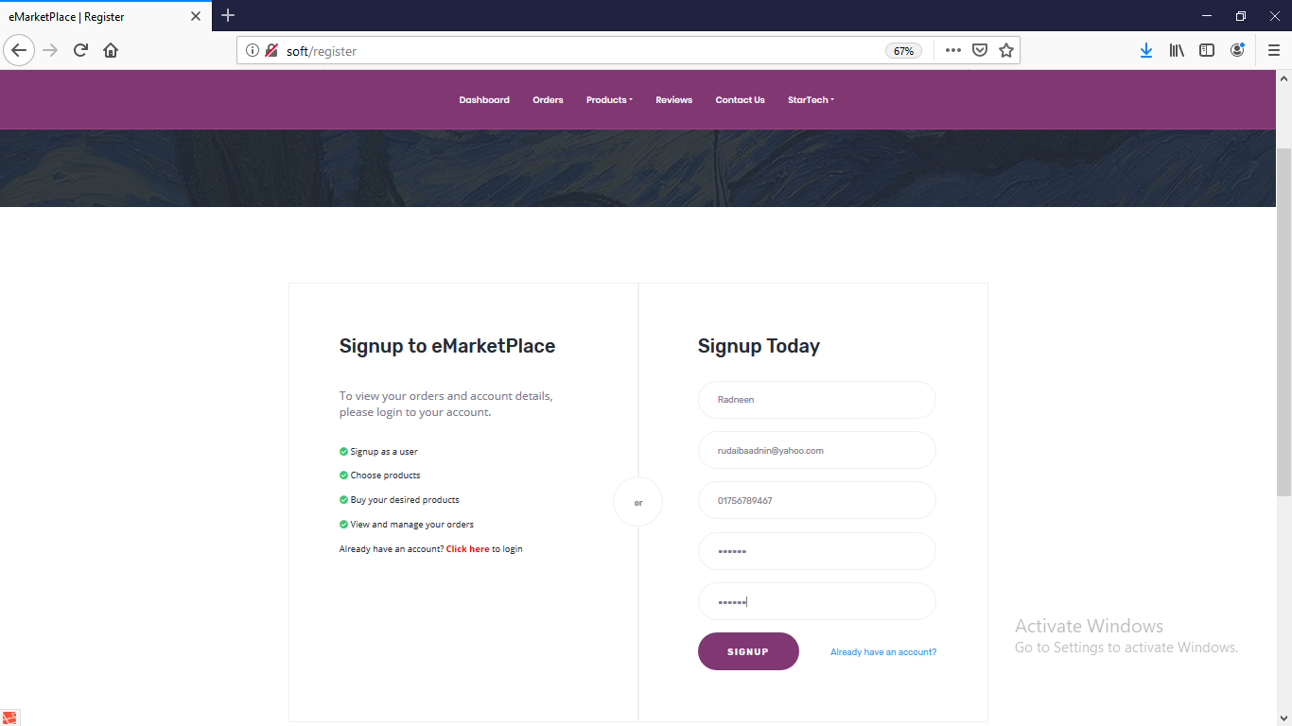

**Home:**

**Profile:**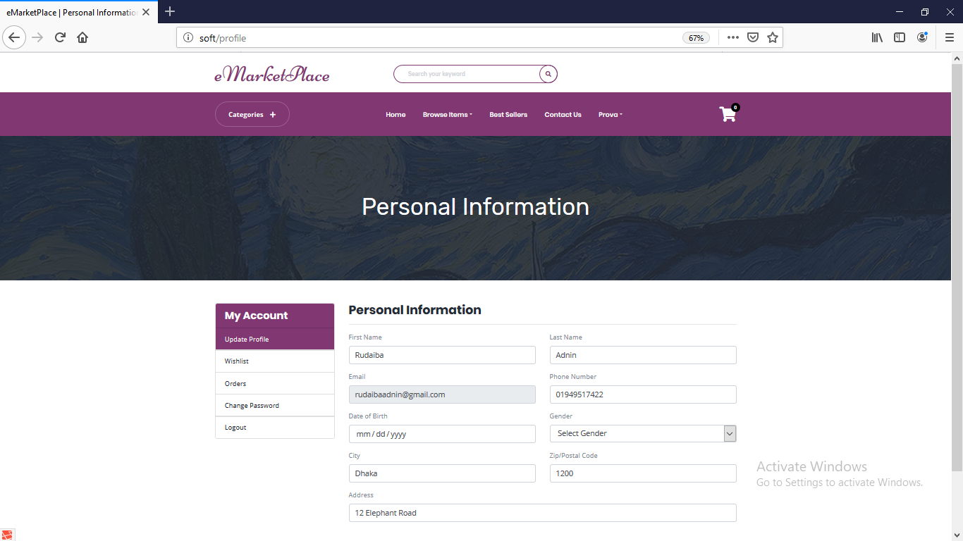

**Browse Items:**

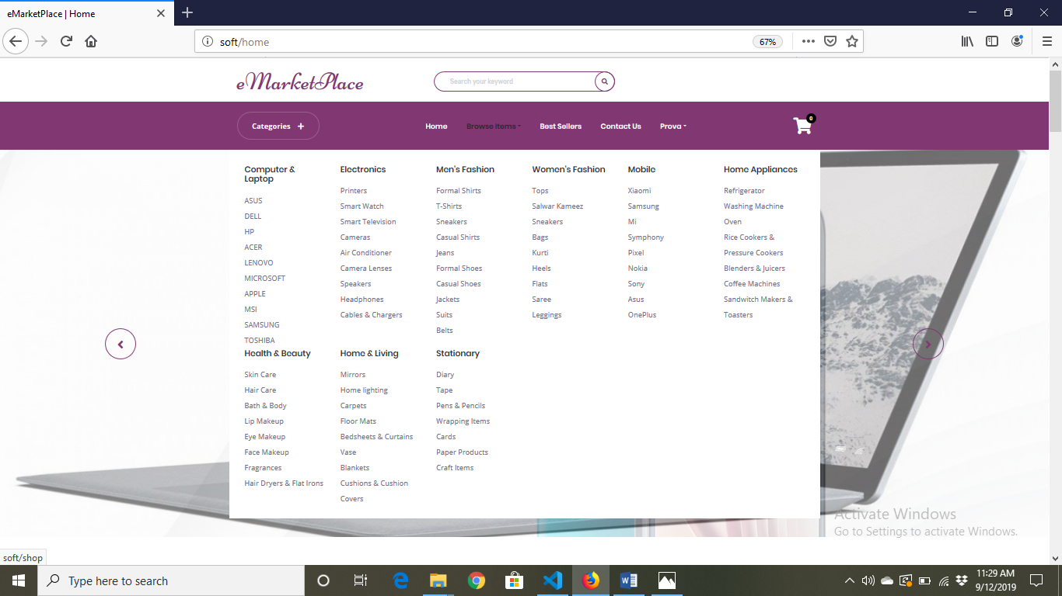

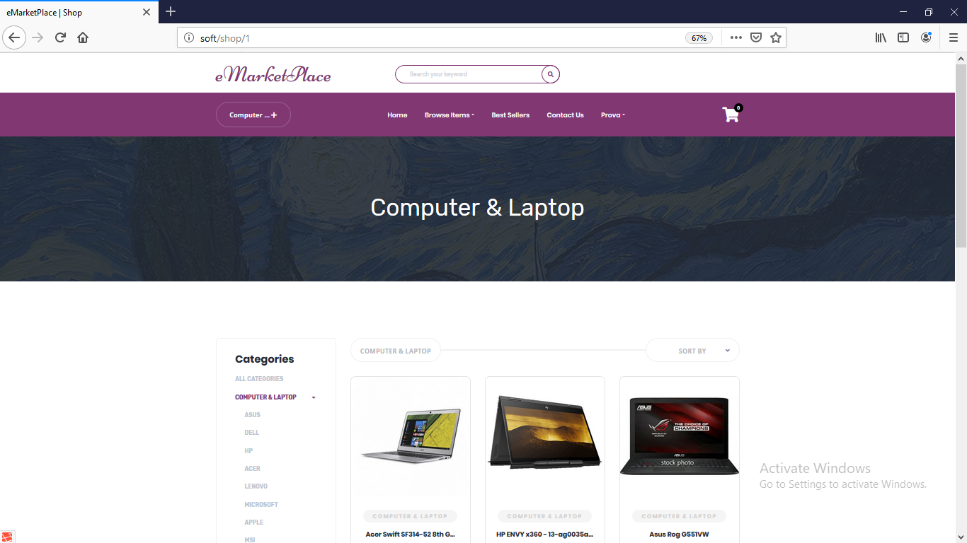

**Wishlist:**

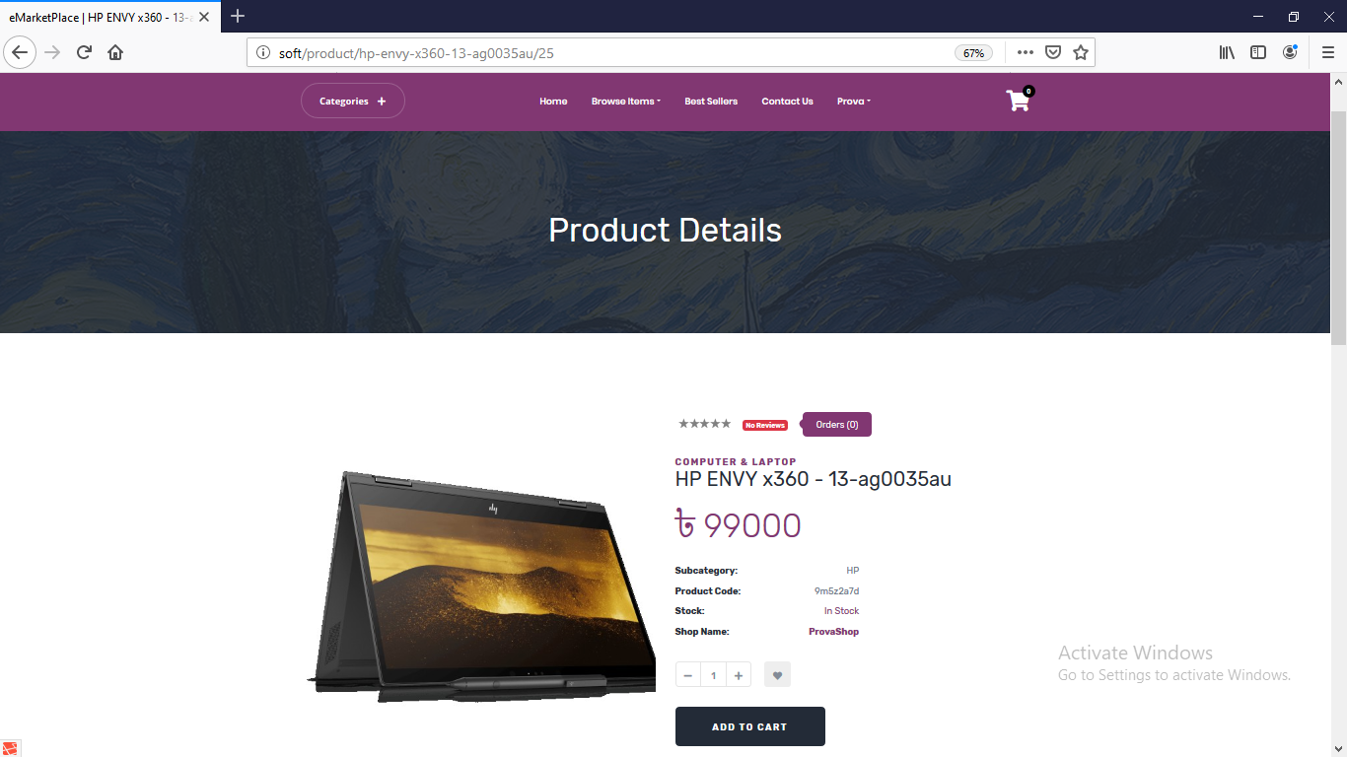



**Add To Cart:** 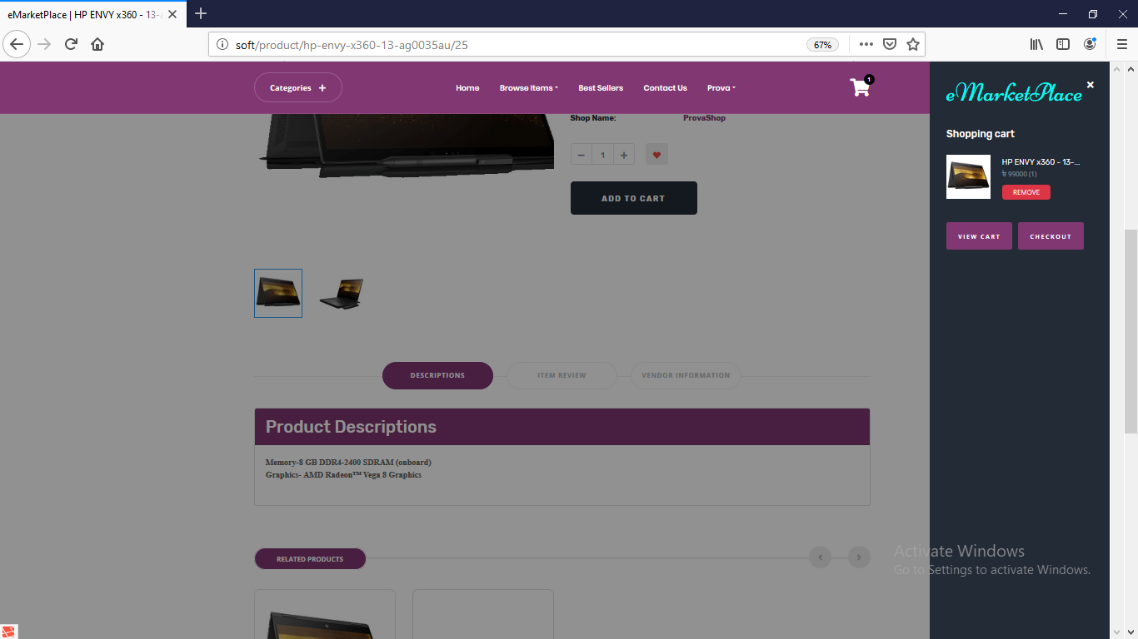

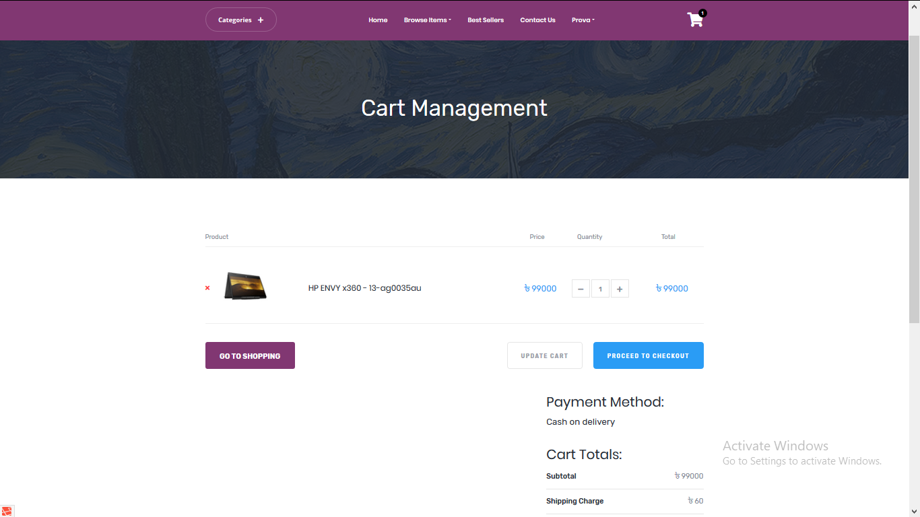

**Checkout:**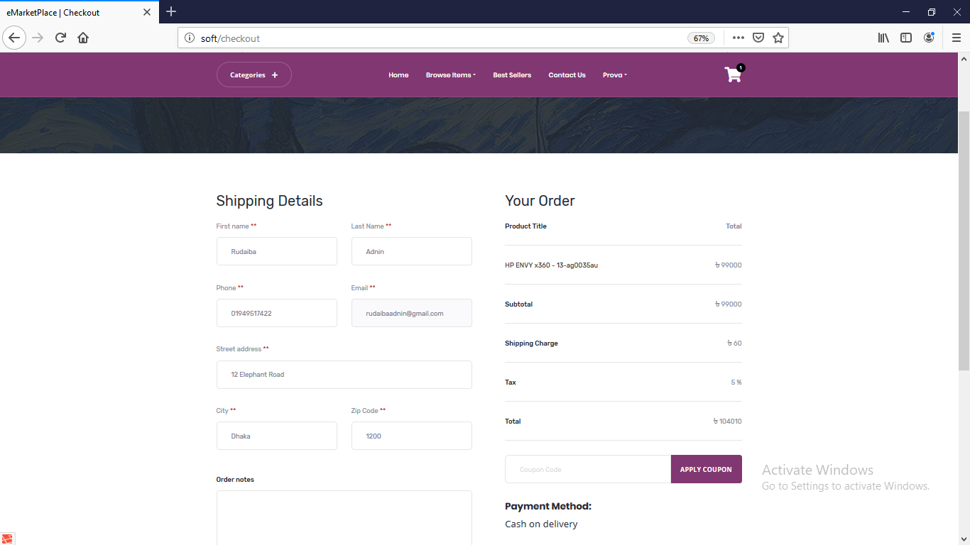

**Orders:**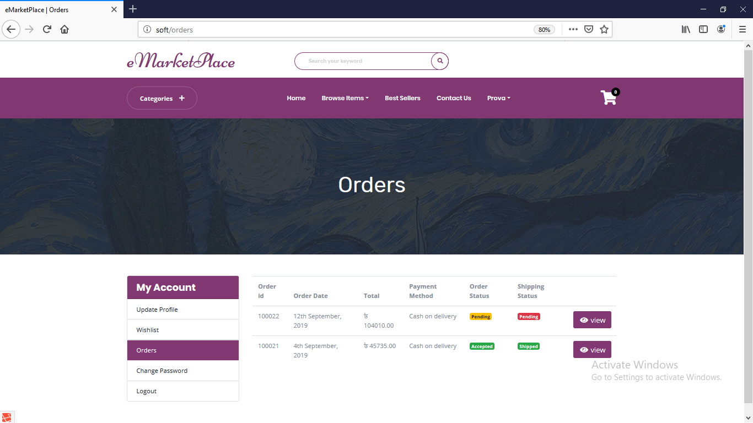

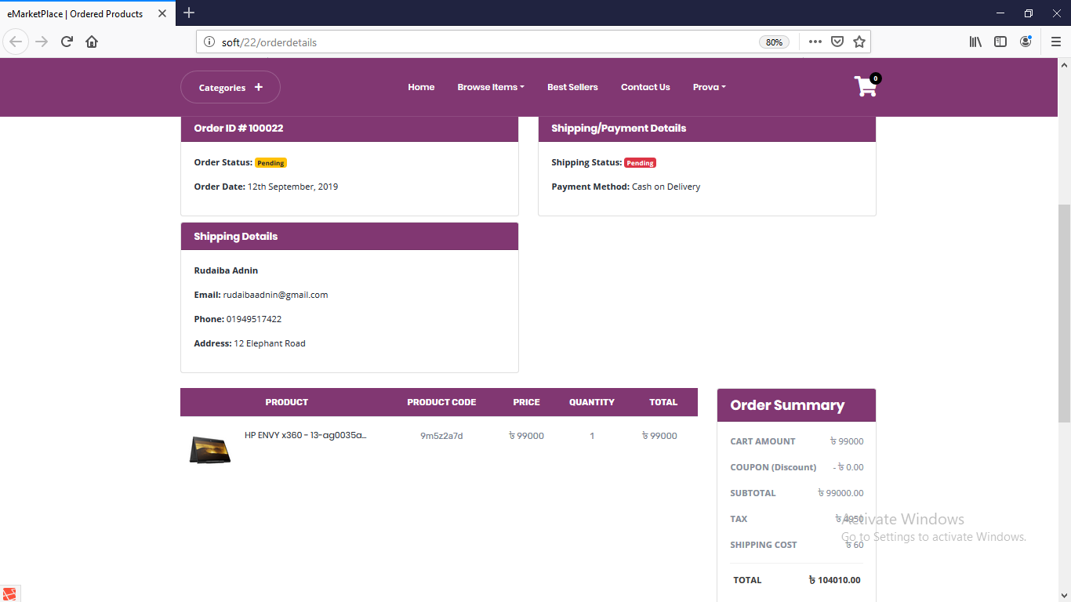

**Write Review:**

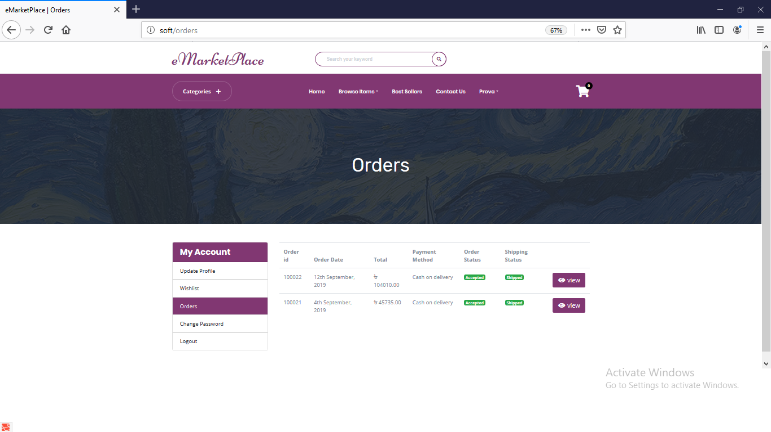

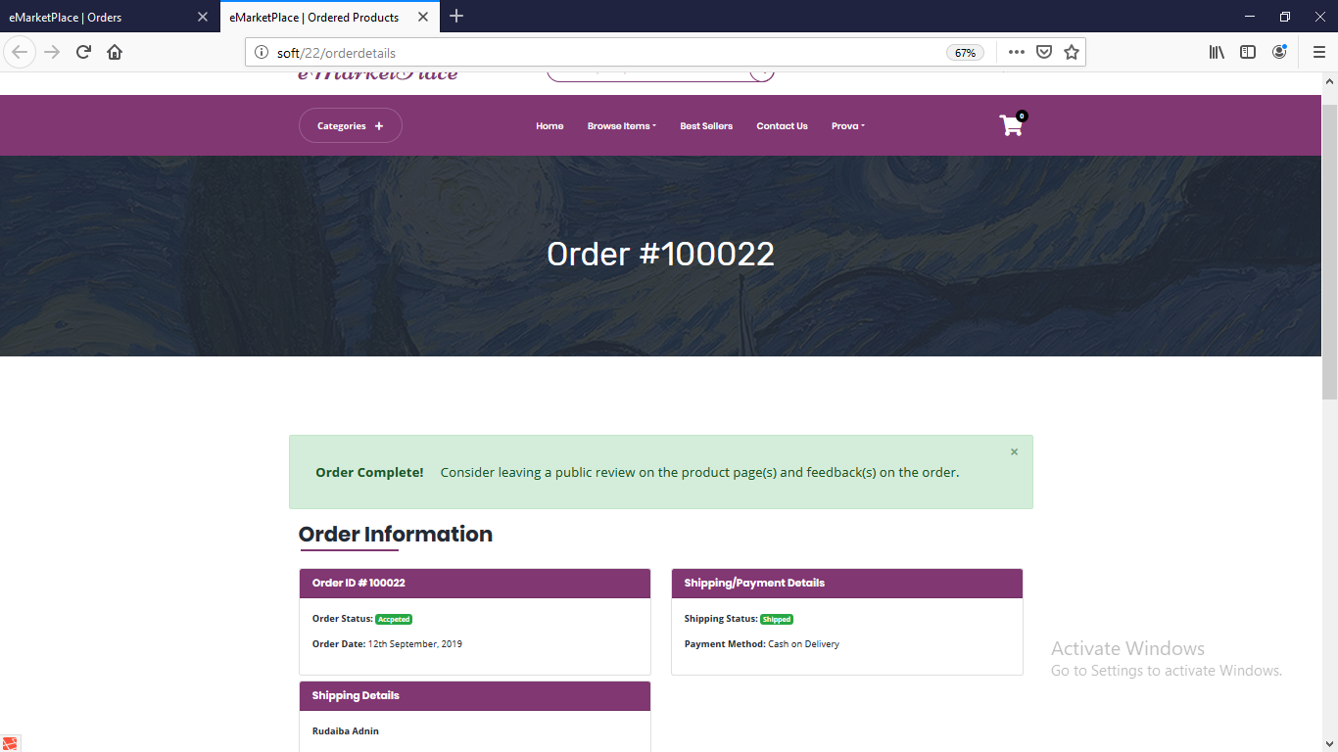

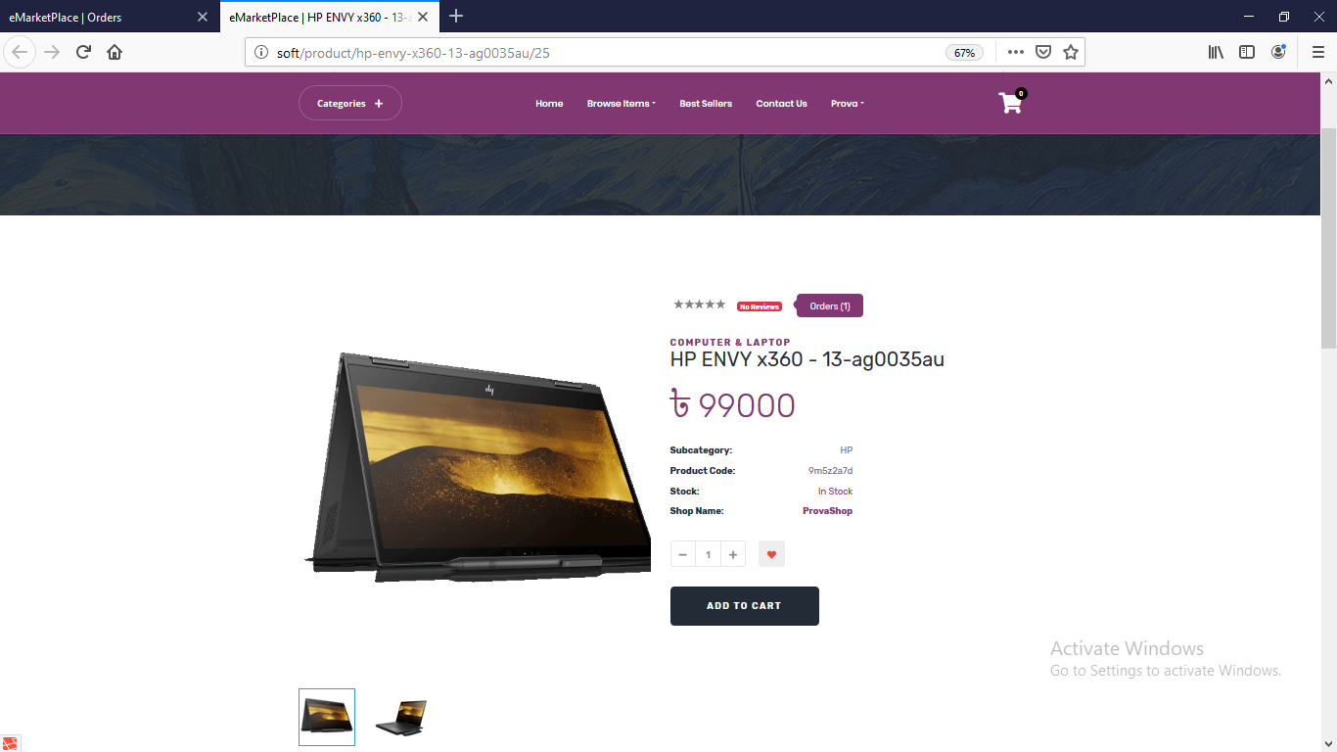

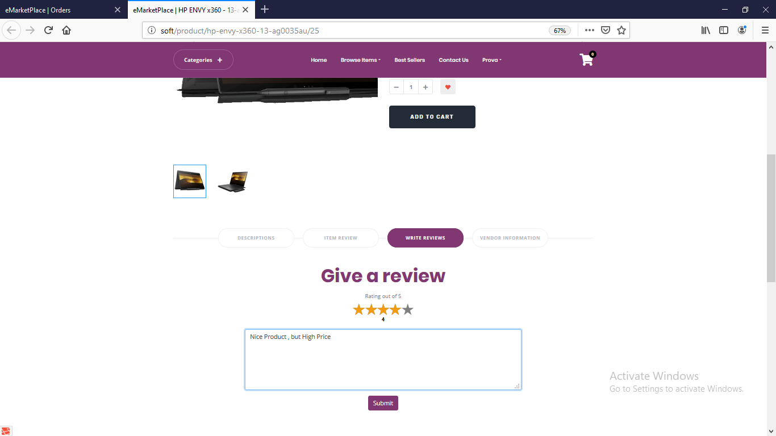

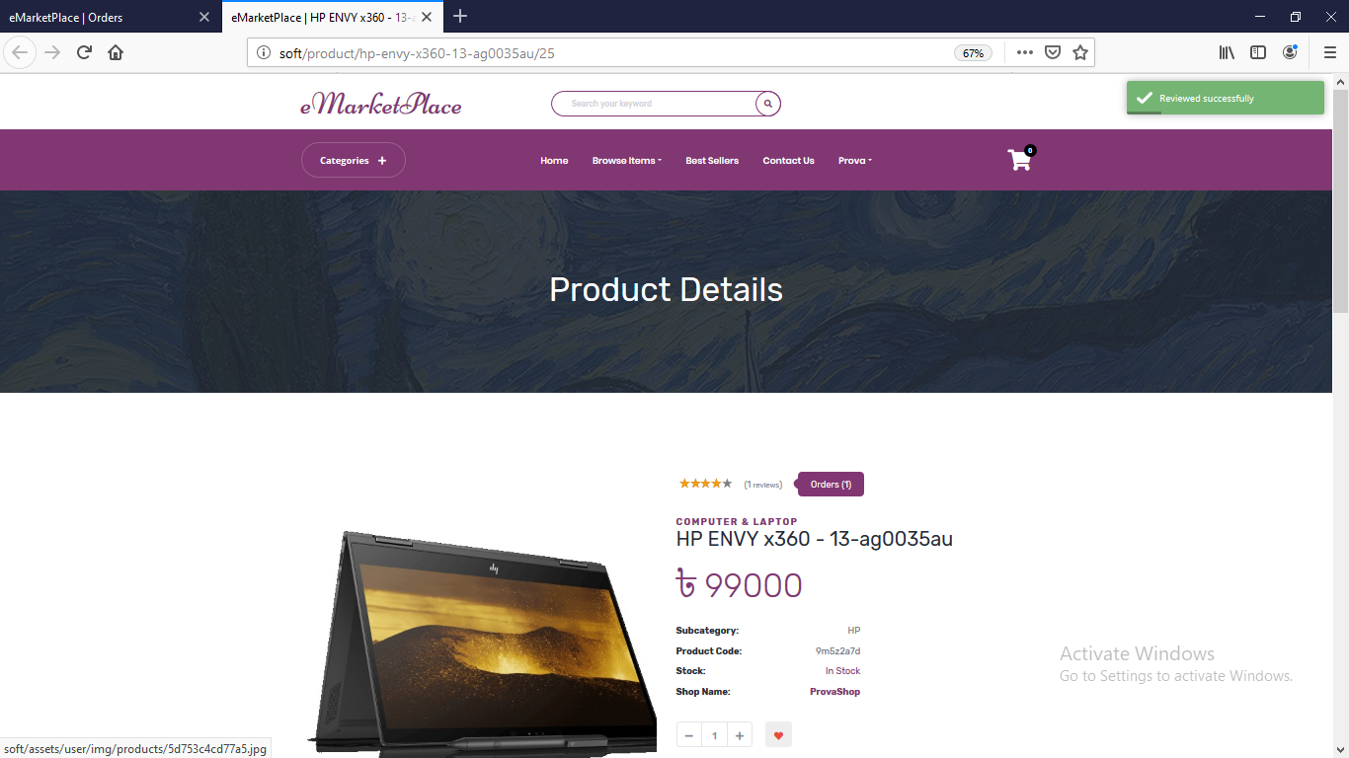

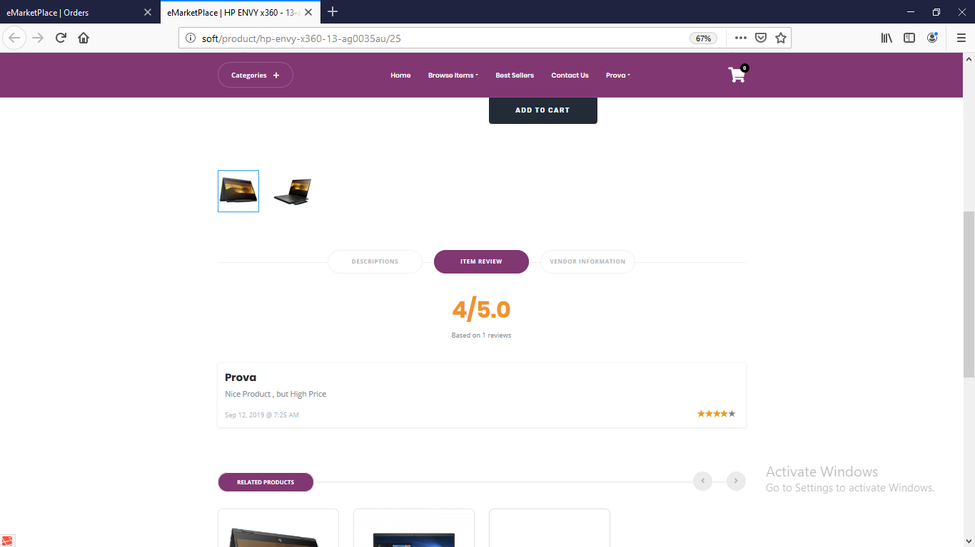

**Give Feedback:**

